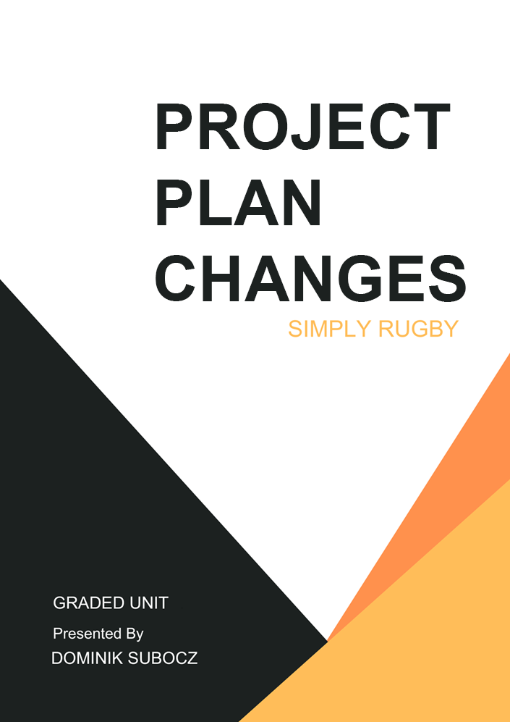

Contents

Changes Made 3

Plan Changes 3

Business Model Changes 3

Business Model Before 3

Business Model After 3

View Model Changes 3

View Model Before 3

View Model After 3

Test Strategy 3

Testing Screenshots 3

# Changes Made

During the development stage, several changes and small adjustments to the project had to be made to improve the project and to make sure it aligns closely with my objectives and meets the requirements of the project.

These changes were based on reviewing how things were going internally, system and functionality overhauls, removing redundant useless stuff from database and website itself and user feedback from testing forms.

## Plan Changes

The most notable changes that I have made during the development stage of the project are changes to the testing plan.

In the plan I have mentioned that I would perform unit and system testing on my web application. I had to abandon both of these testing methods given that, one; I did not have much time left because I have left testing for last week or so, two; I had no idea how to unit test PHP code.

Instead, I have decided to swap these two methods of testing with component and database testing. In the component testing document I was just basically confirming that each component like images, fonts, styles, scripts, html cards load correctly. While database testing was all about testing SQL queries and seeing if the actual result is same or different as the expected result.

## Business Model Changes

During the development stage, I have also made some notable changes to the business models. The only diagram that I believe was left unchanged was the Data Binding diagram, mainly because I believe that it was still conveying still idea even with all the changes made to the web app.

### Business Model Before

This section focuses on showcasing the diagrams designed for the planning stage.

#### Activity

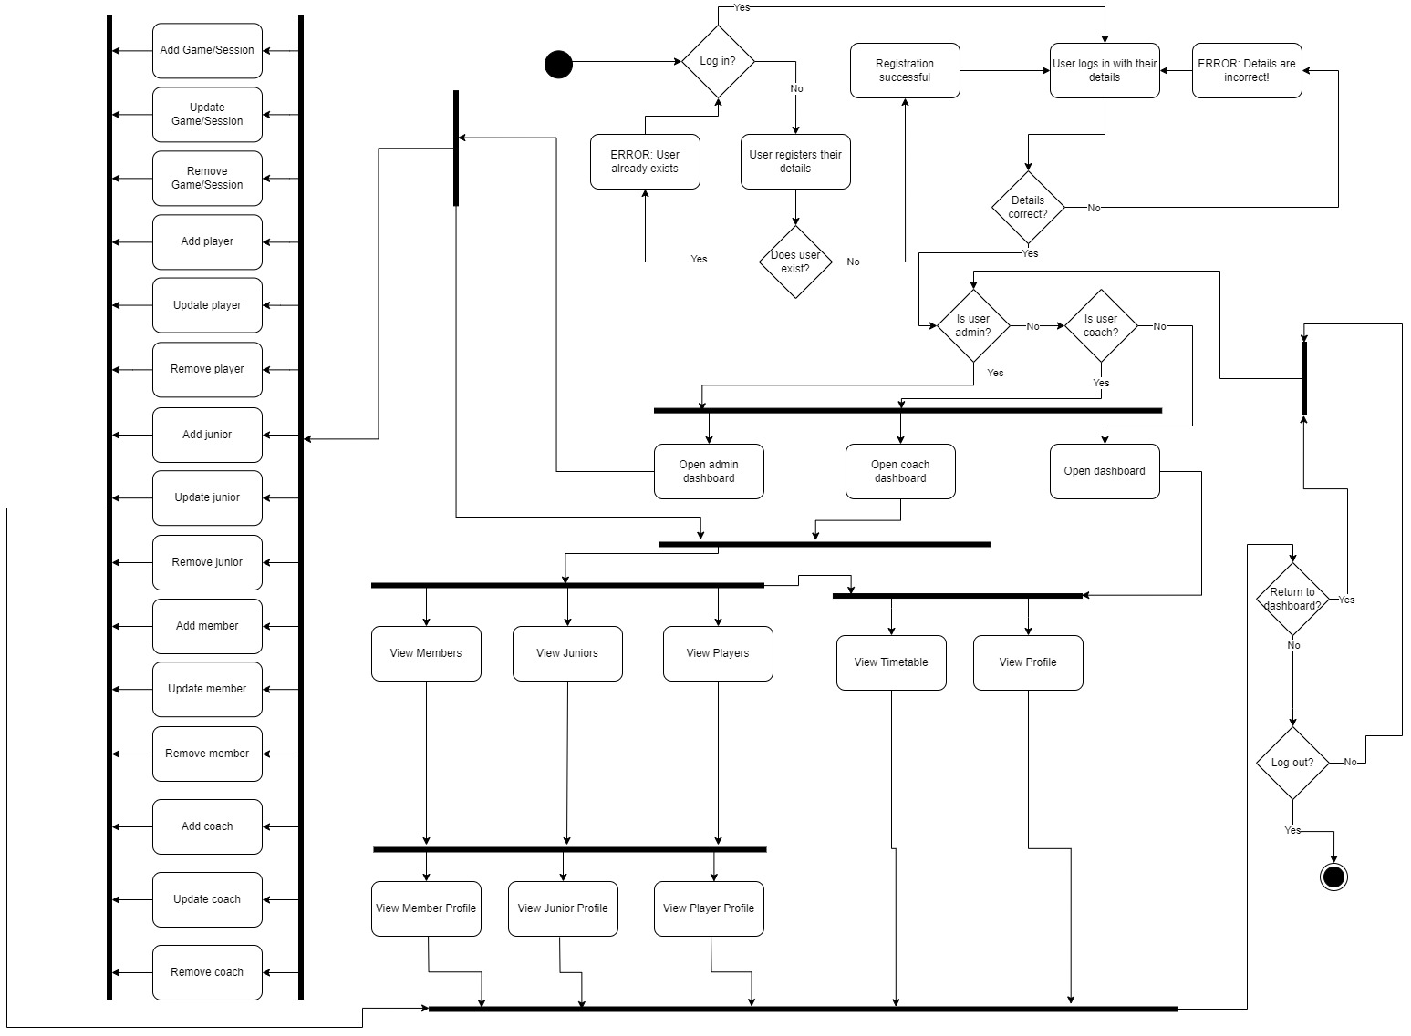

#### Entity Relationship Diagram

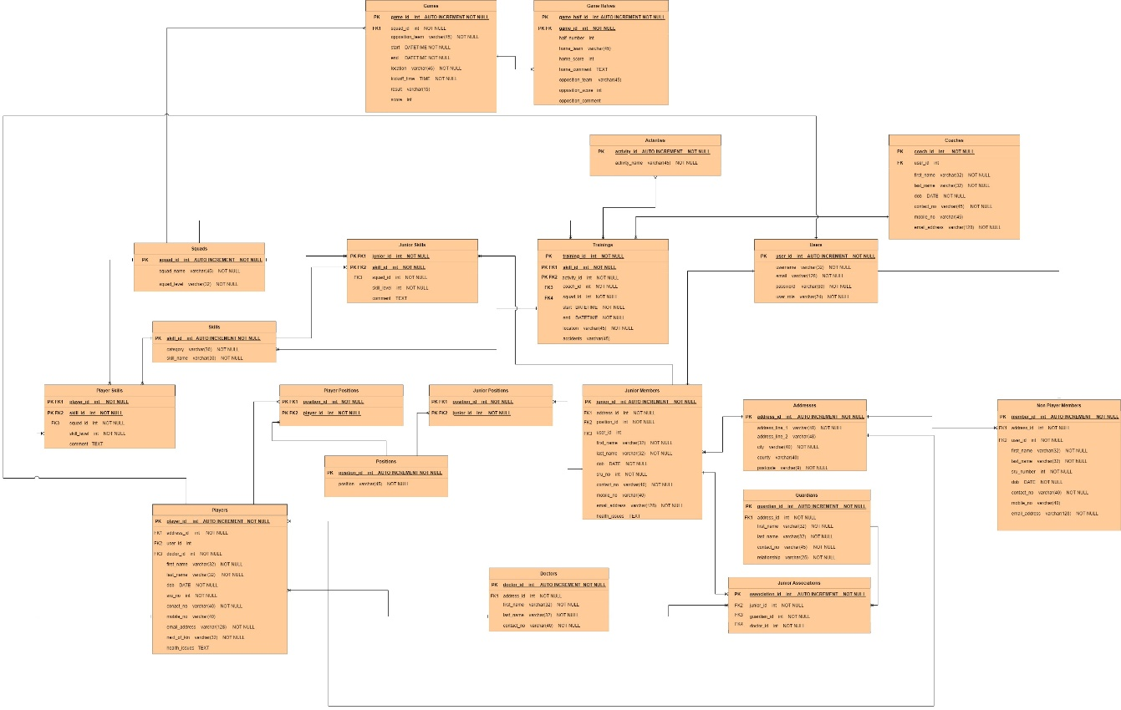

#### Site Map

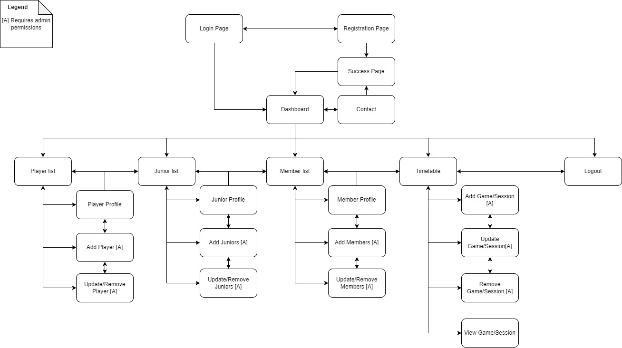

#### Use Case

**Player Management:**

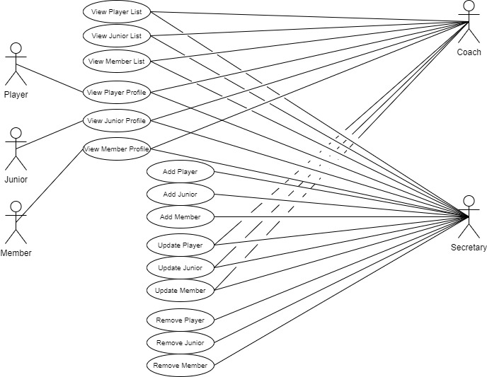

**Event Management:**

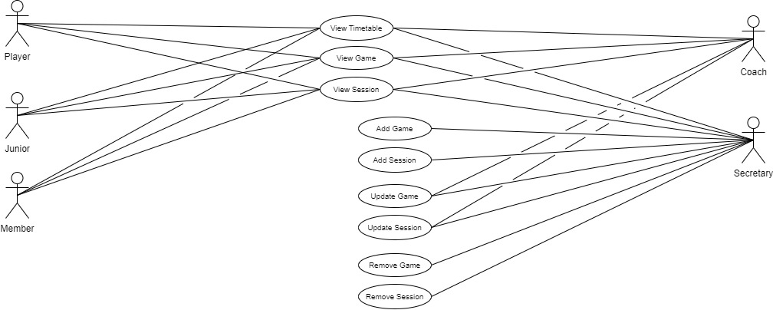

### Business Model After

This section focuses on showcasing the updated diagrams made at the end of the development stage.

#### Activity

I have decided to split the activity diagram into smaller bits to aid readability. The smaller diagrams have also been expanded based on the functionality and state of the current system, replicating how the system works almost identically.

**Senior / Junior Player Management System**

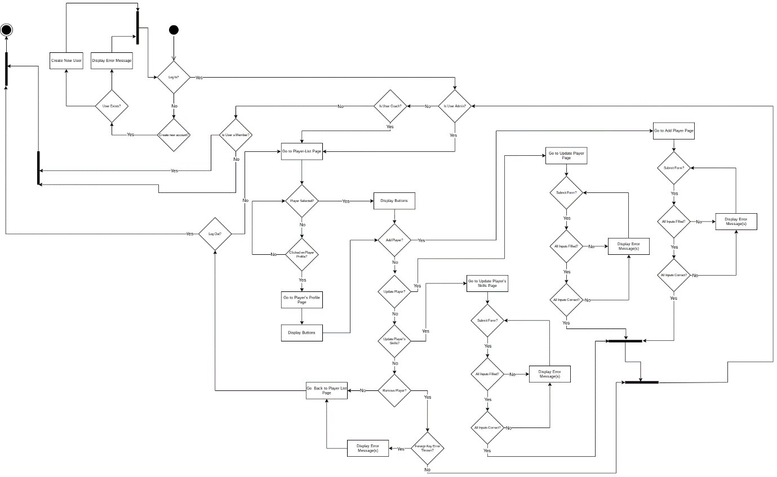

**Member Management System**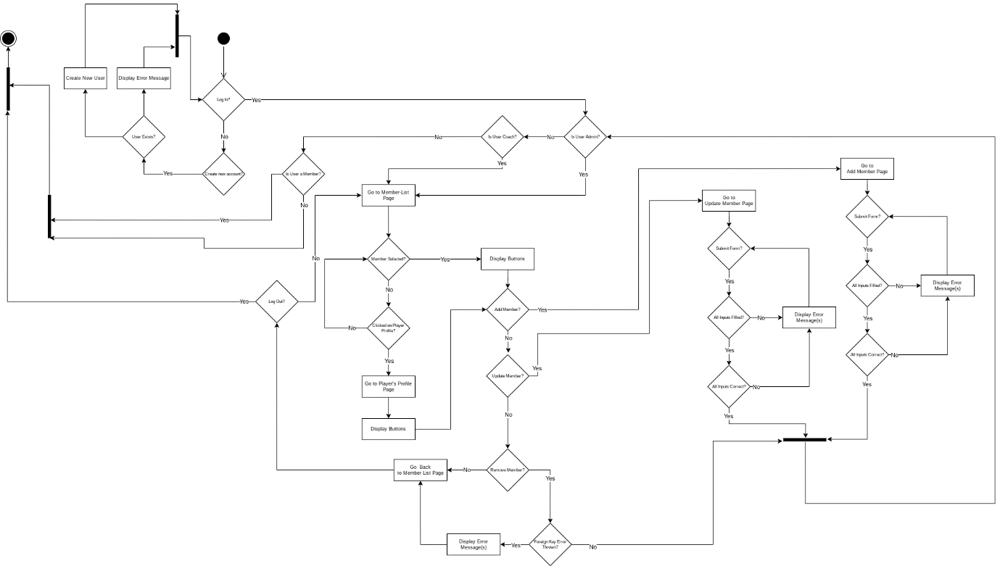

**Event Management System**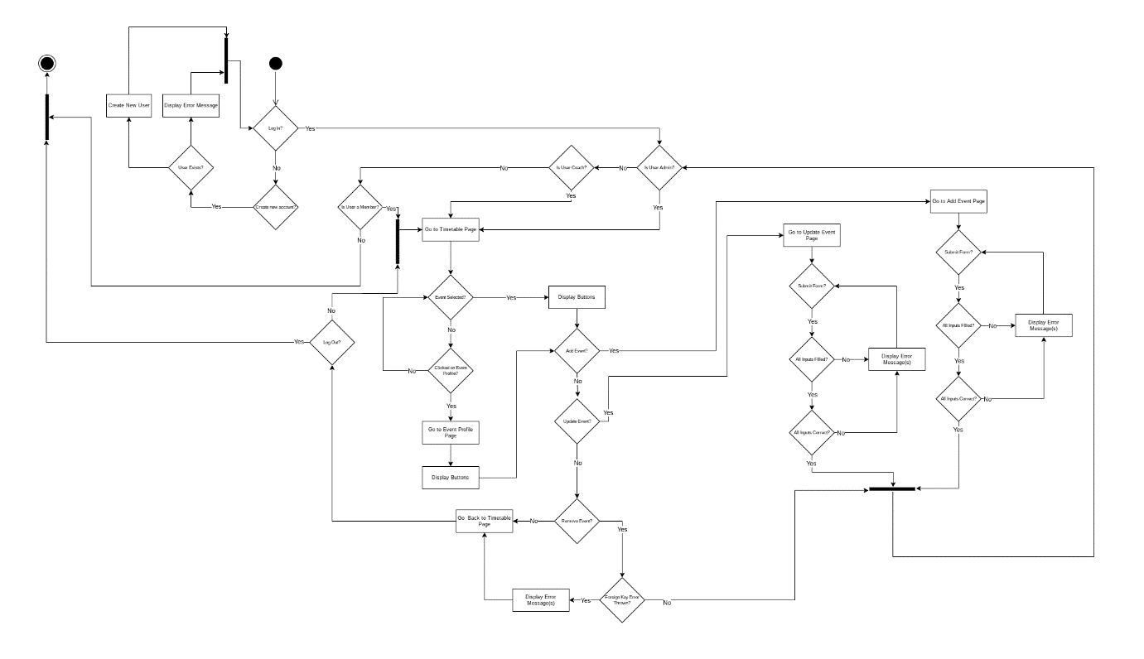

**Data Management (Addresses, Guardians, Doctors)**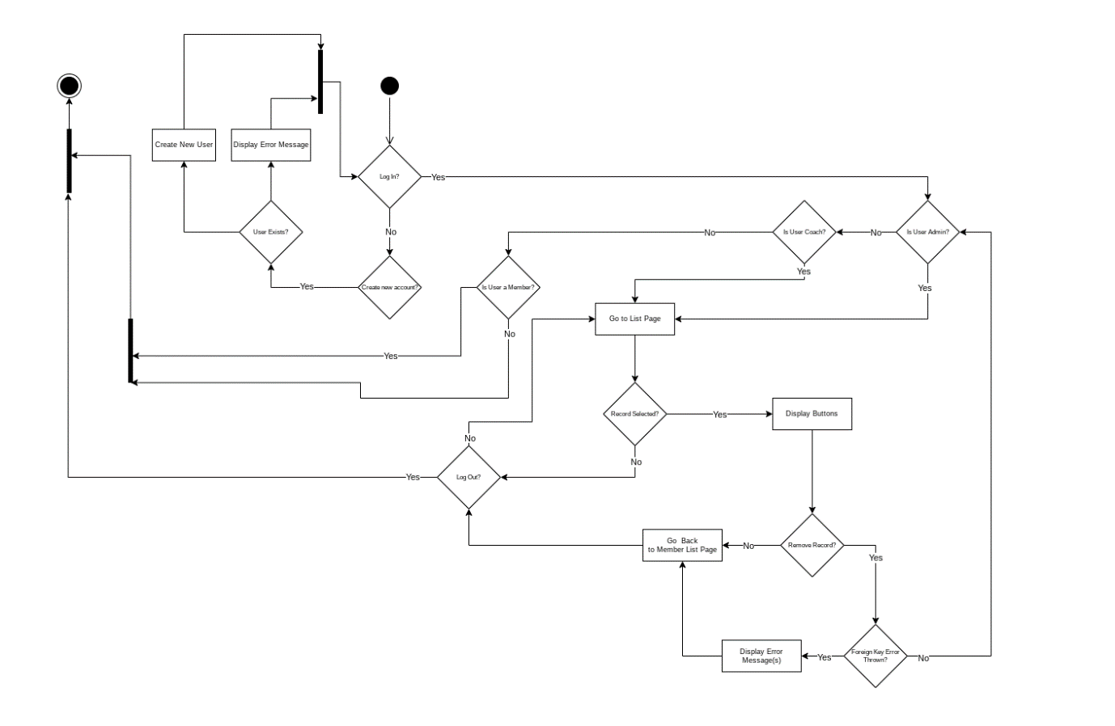

#### Entity Relationship Diagram

Updates made to the ERD diagram mainly include taking out useless fields or creating new tables/fields.

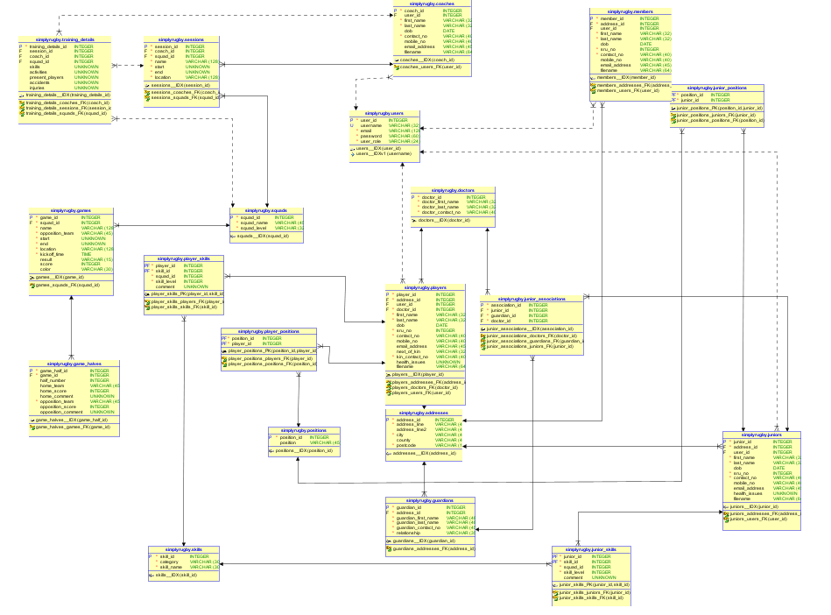

#### Site Map

The site map of the whole web app has expanded substantially, mainly as a result of new pages being added to the project.

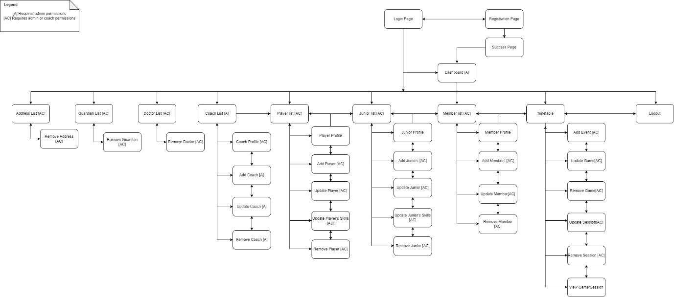

#### Use Case

The diagrams below, also have expanded just like the sitemap previously mentioned. With a live working version of the system, I was able to more clearly replicate each user scenario. I have ran out of time to implement the missing small features, but I will talk about that in the evaluation report.

**Player Management:**

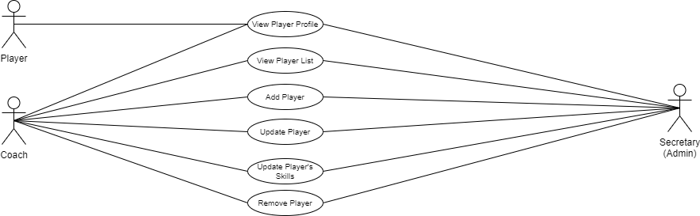

**Junior Player Management:**

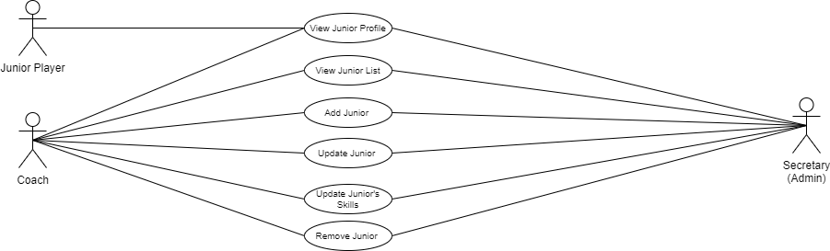

**Non-player Member Management:**

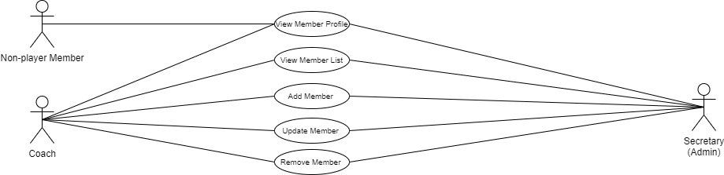

**Event Management:**



**Data & Coach Management:**

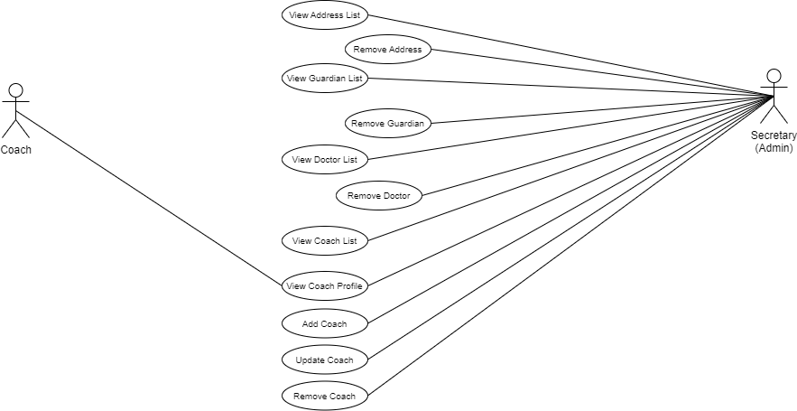

## View Model Changes

In the planning document I have said that the final product would be in similar style like the mock designs I quickly created, but wouldn’t be similar in terms of layout, etc.

Some view models might be slightly different than the wireframes created for the planning stage.

### View Model Before

**Mock / Inspirational Designs**

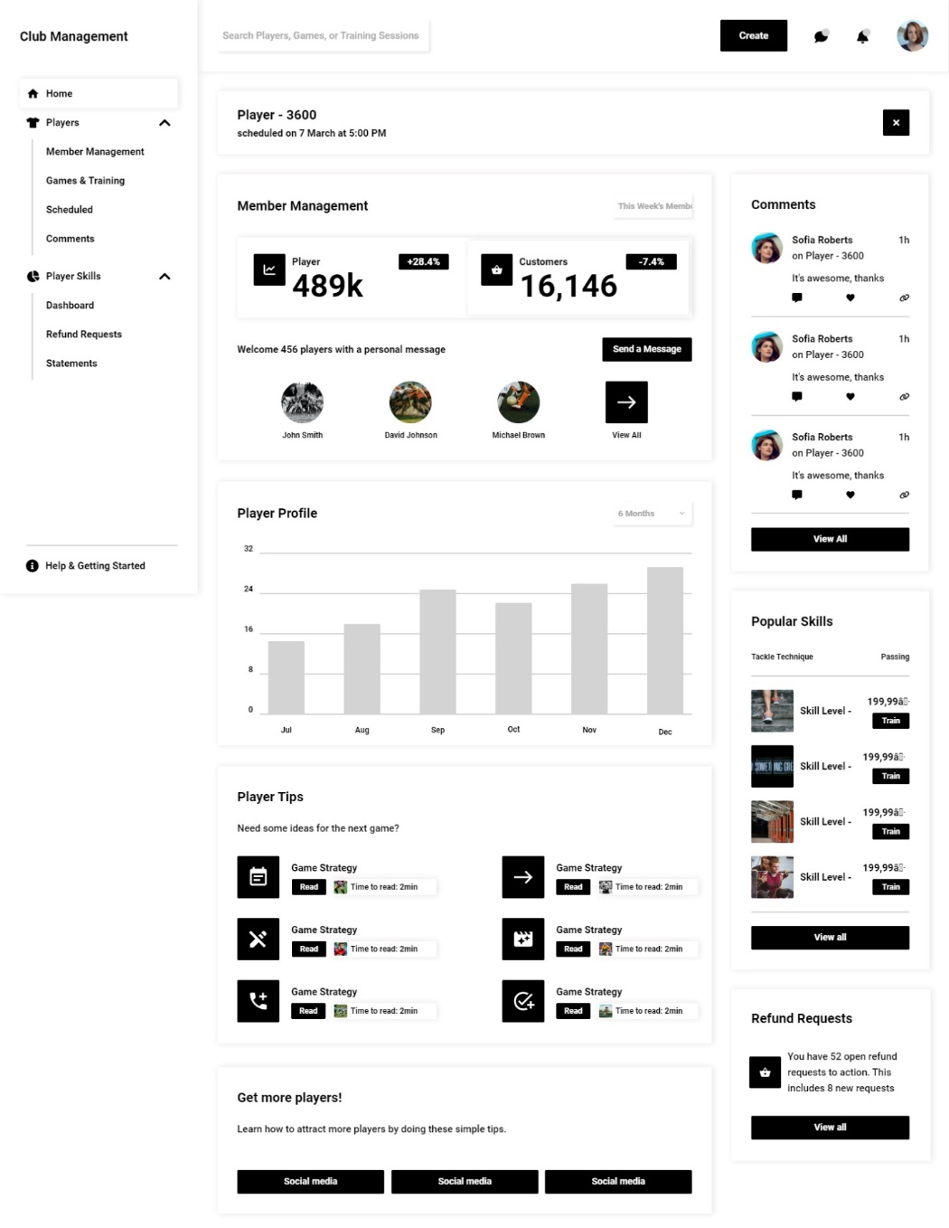

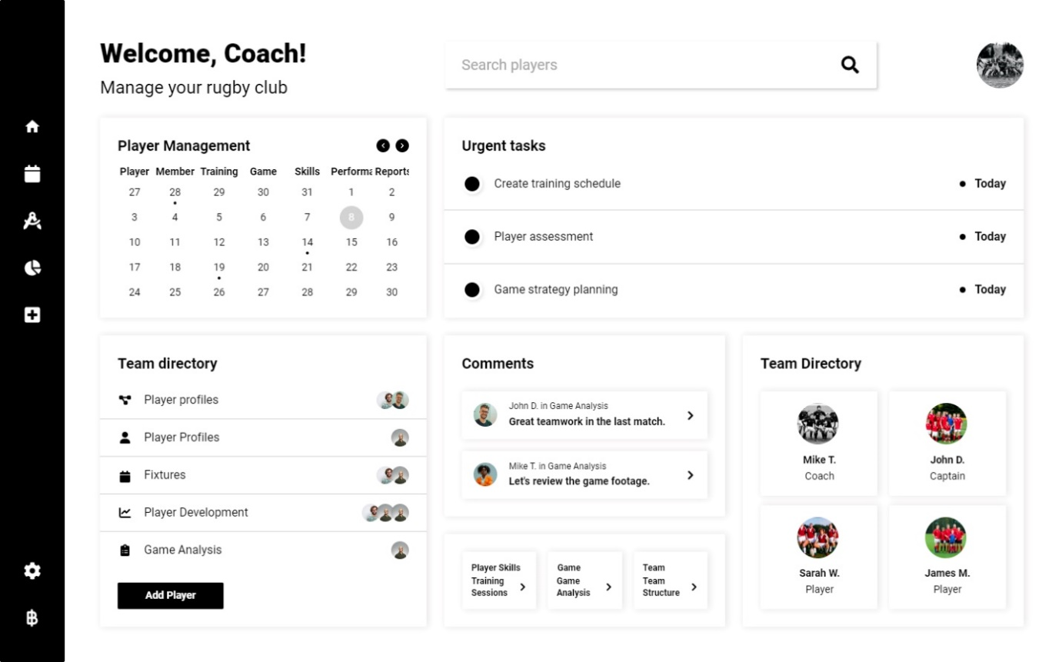

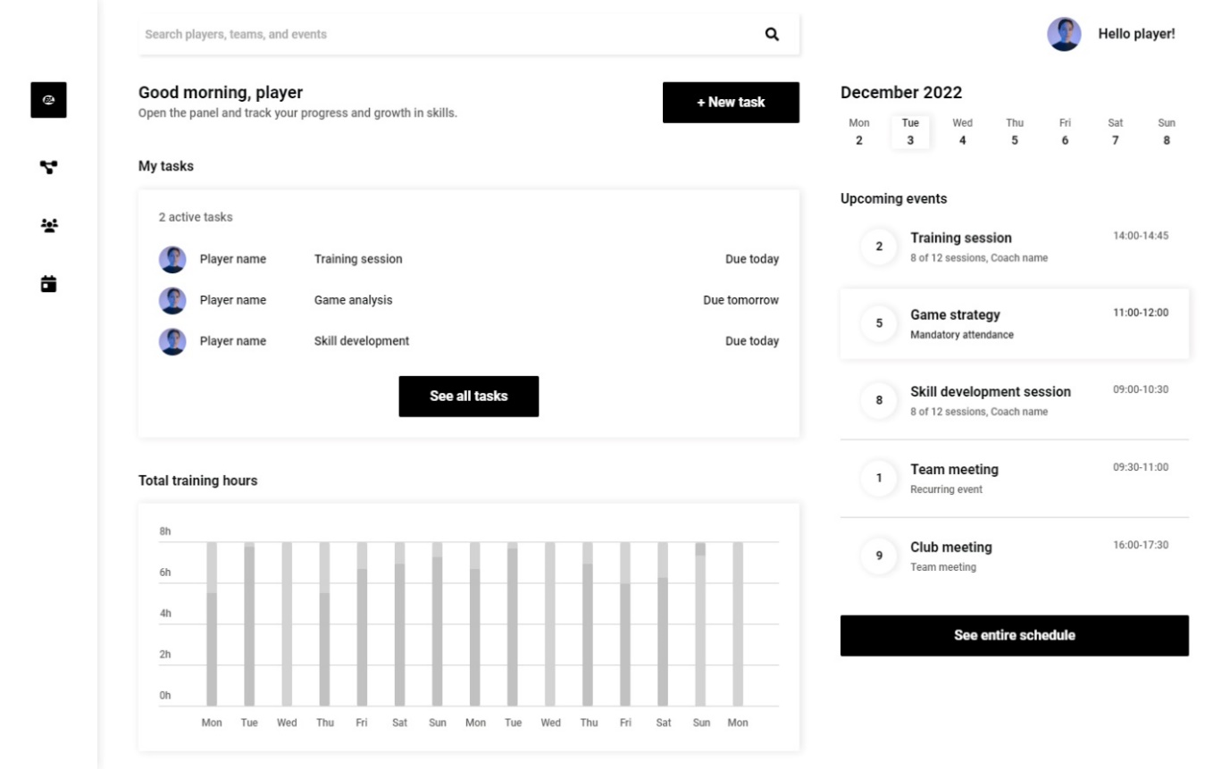

**Wireframes**

**Player/Junior/Member – Dashboard**

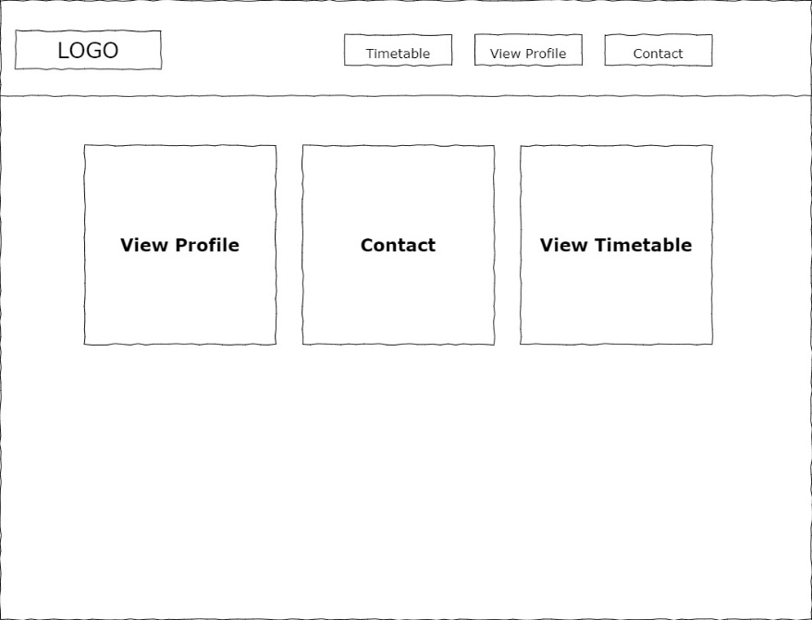

**Coach Dashboard**

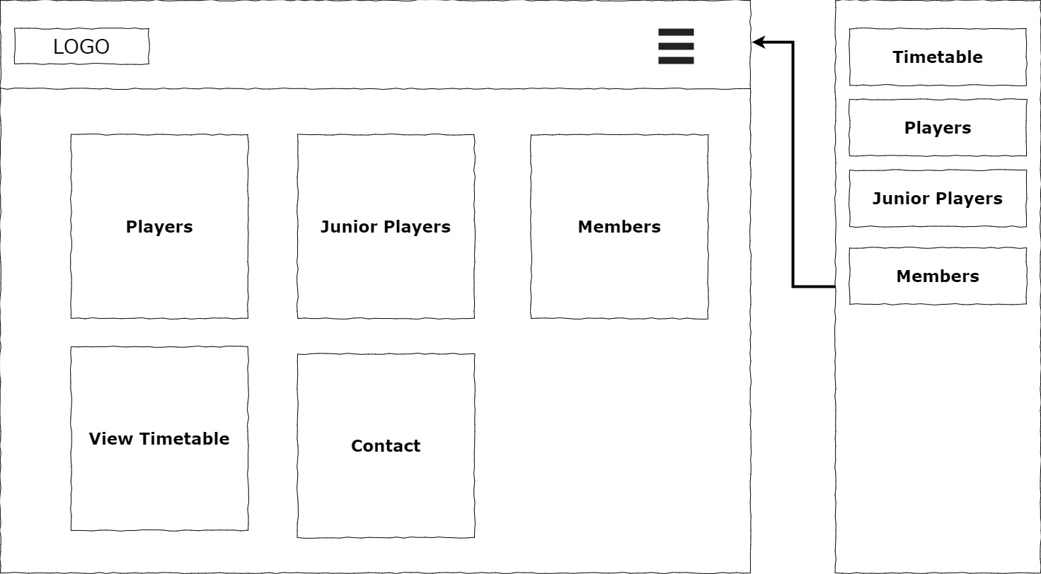

**Admin Dashboard**

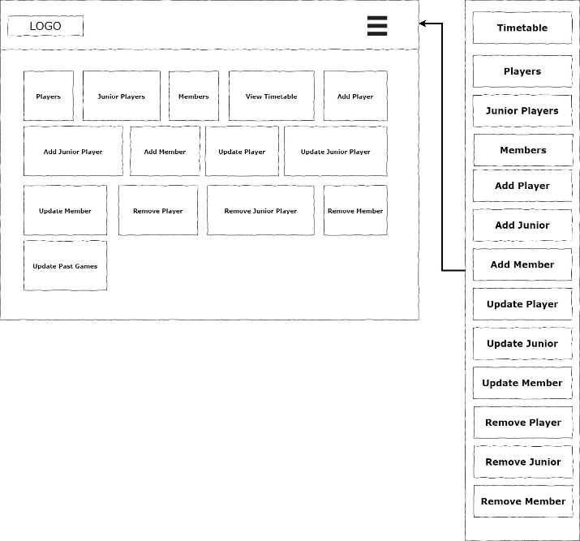

**Players List**

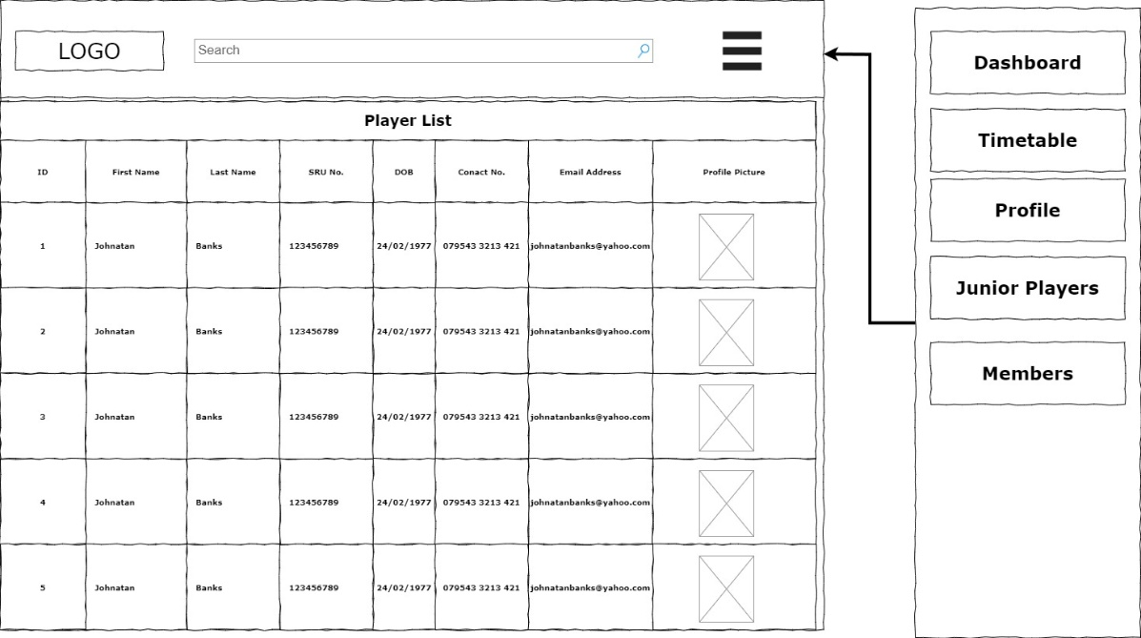

**Juniors List**

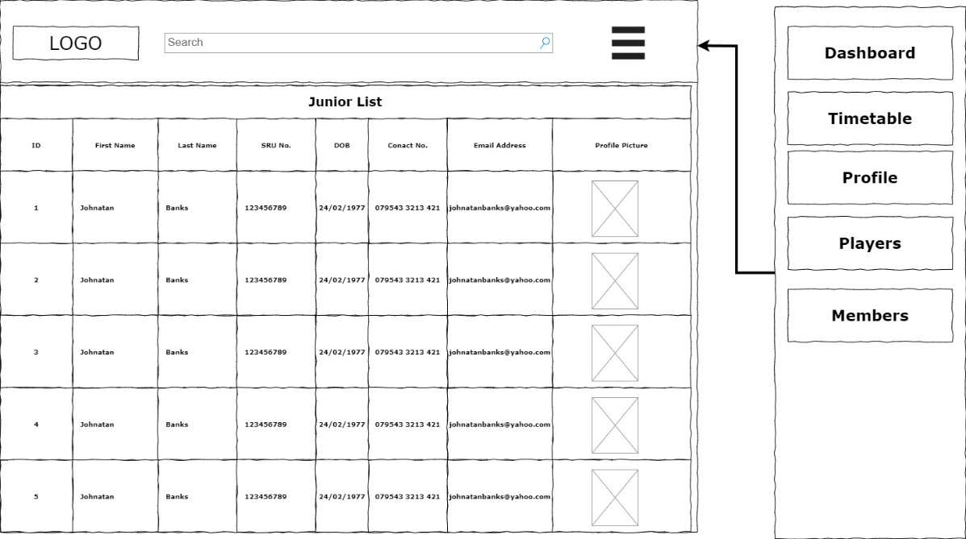

**Members List**

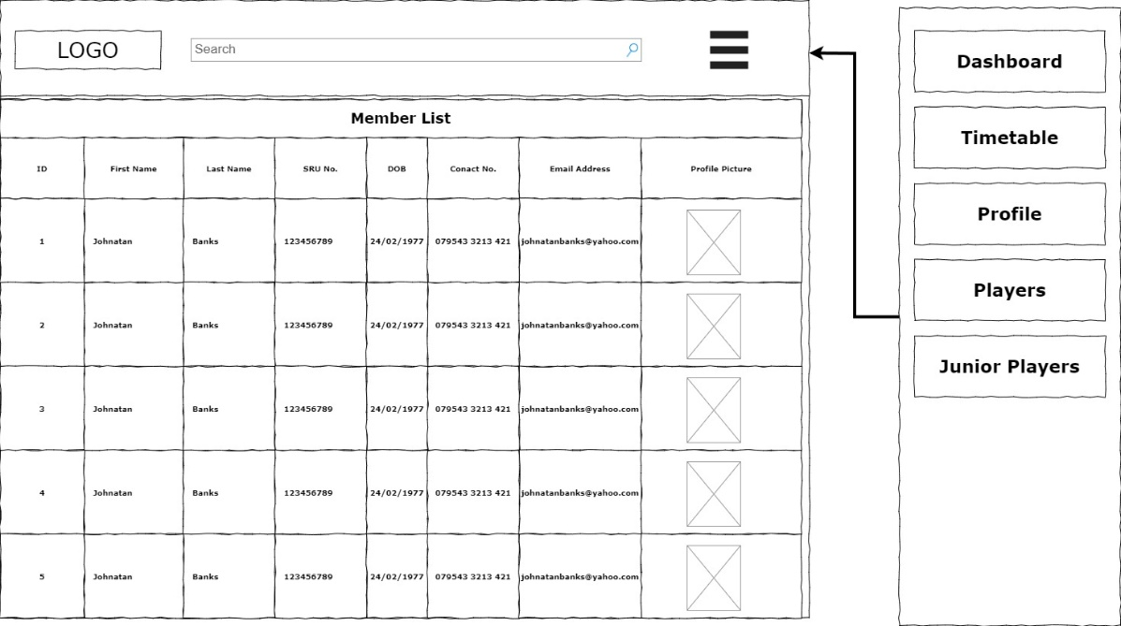

**Player Profile**

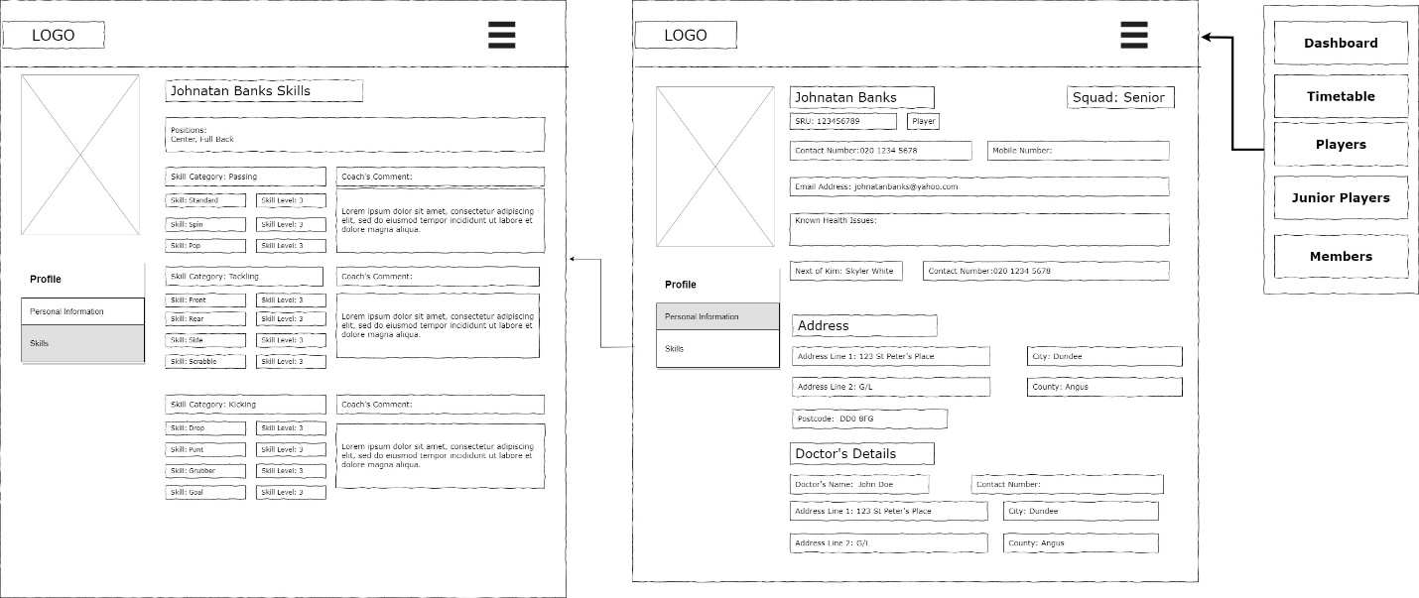

**Junior Profile**

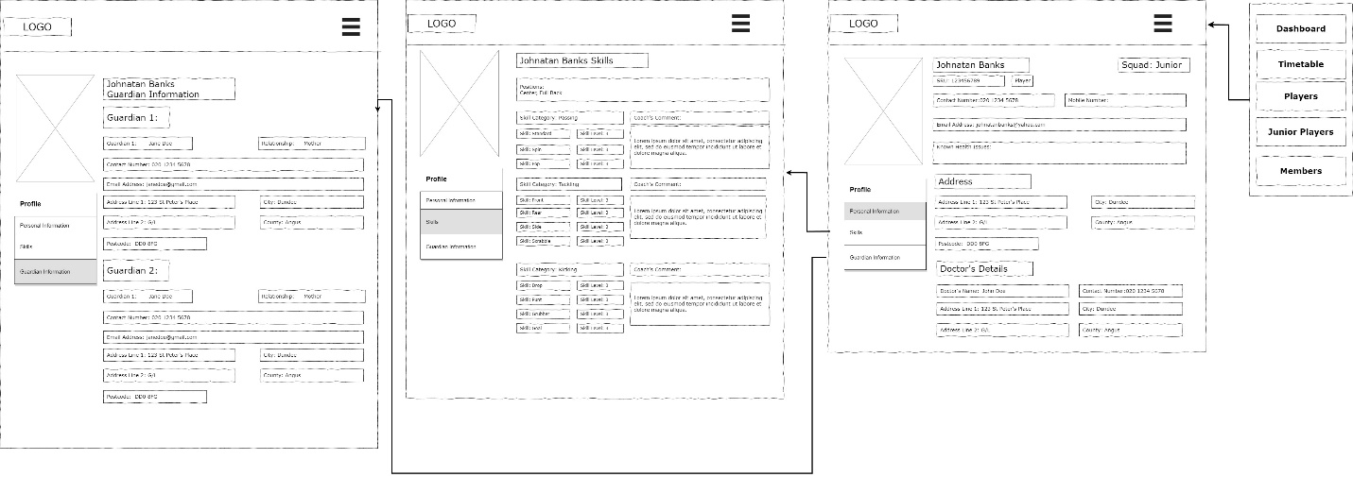

**Member Profile**

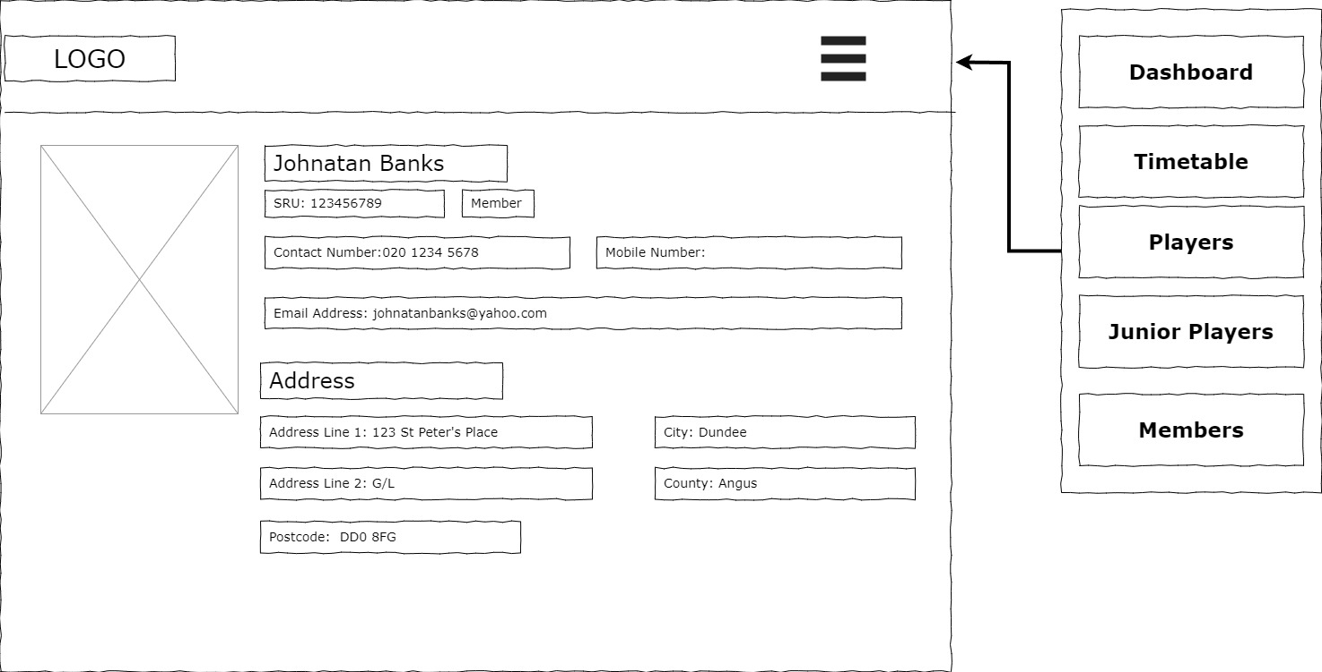

**Add Player**

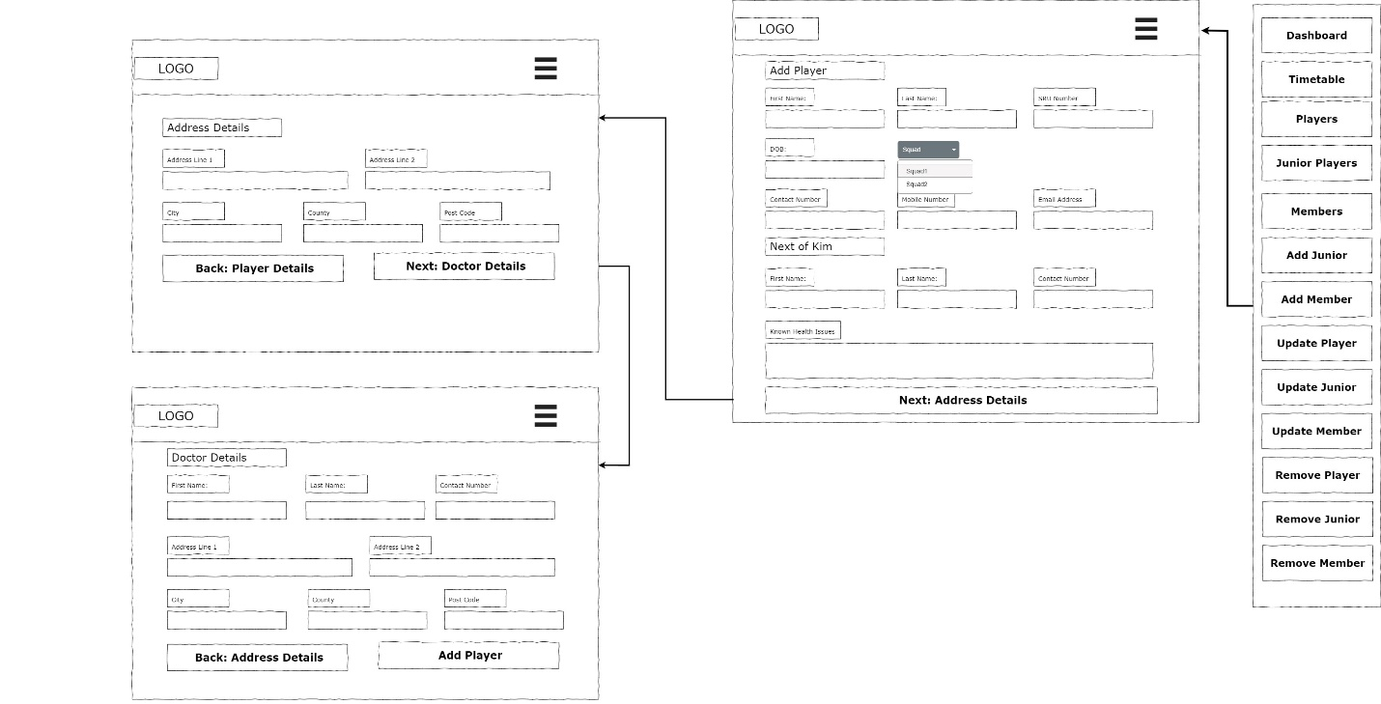

**Add Junior**

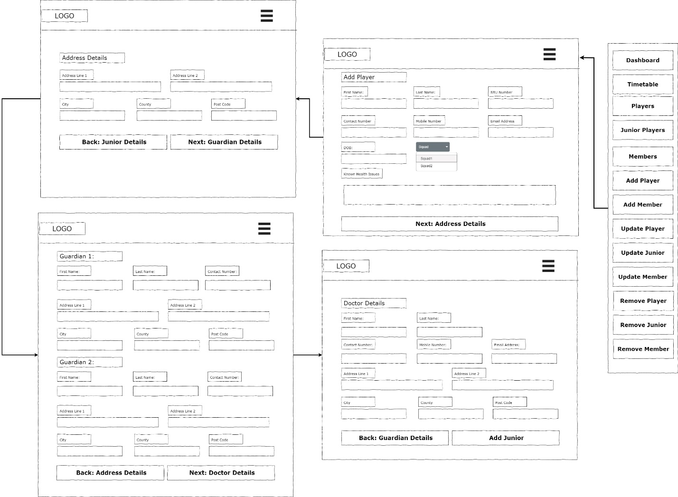

**Add Member**

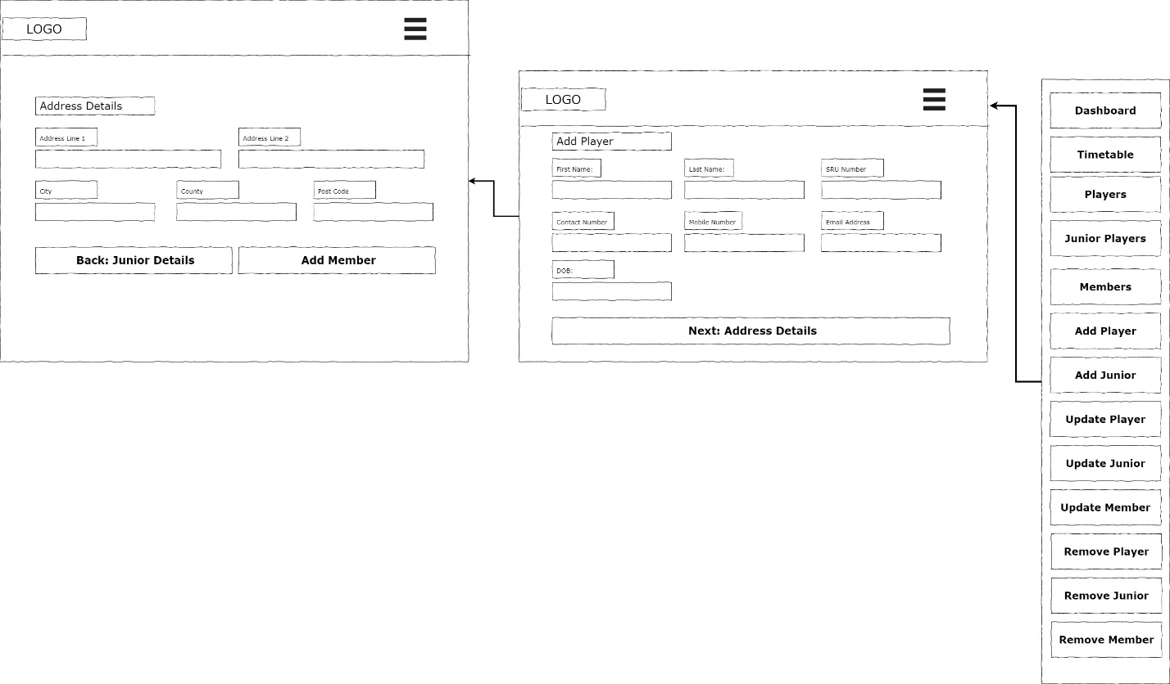

**Update Player**

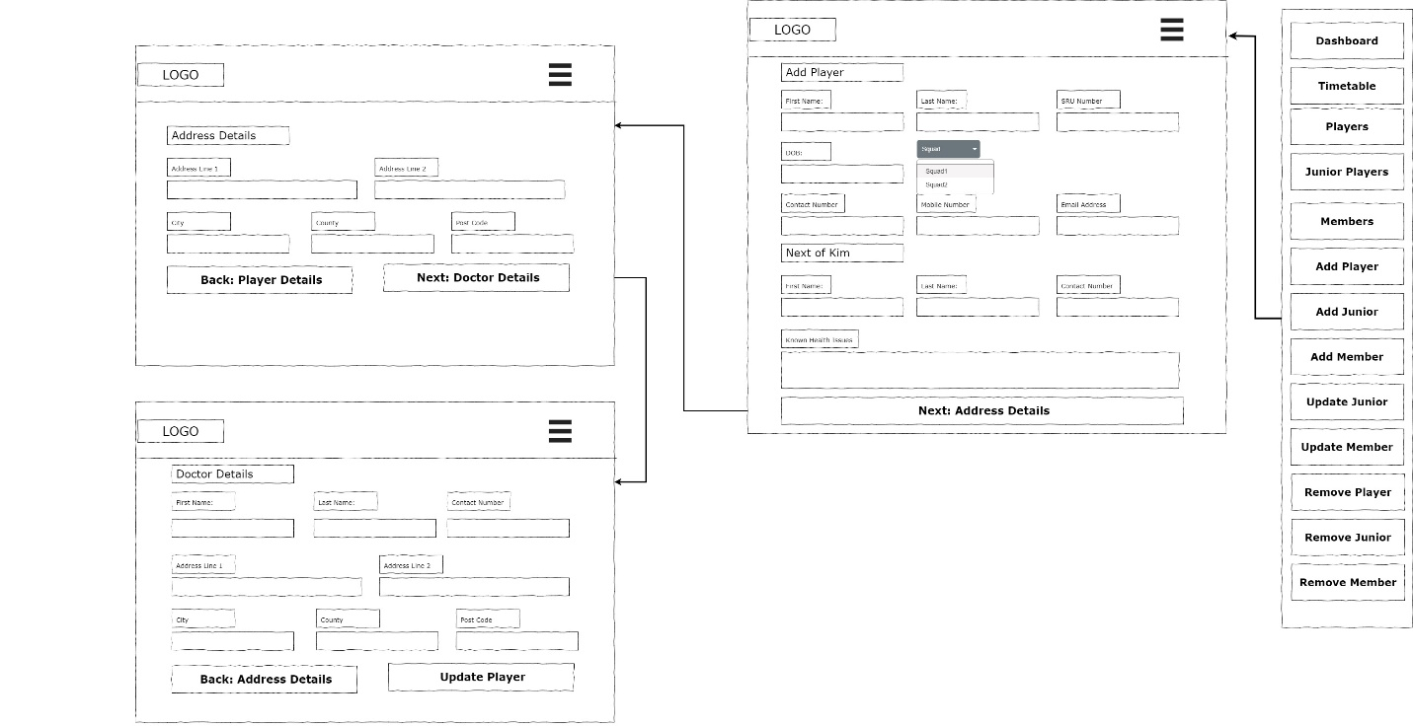

**Update Junior**

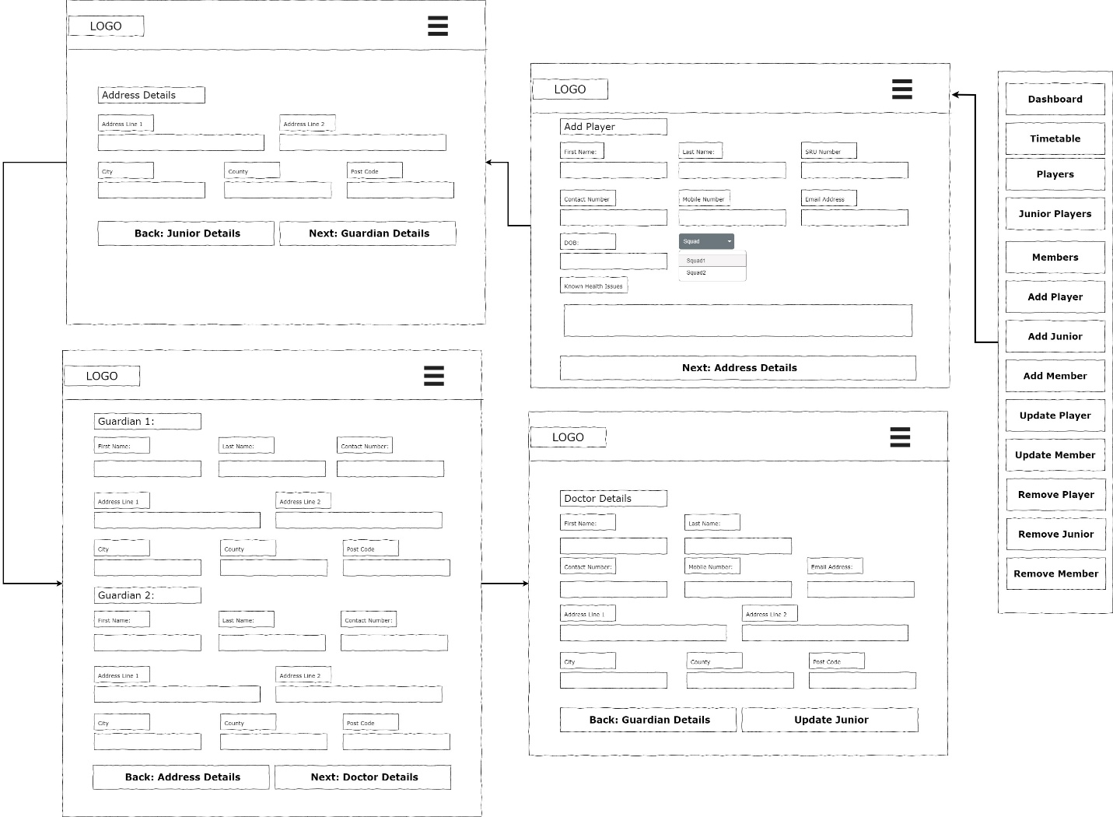

**Update Member**

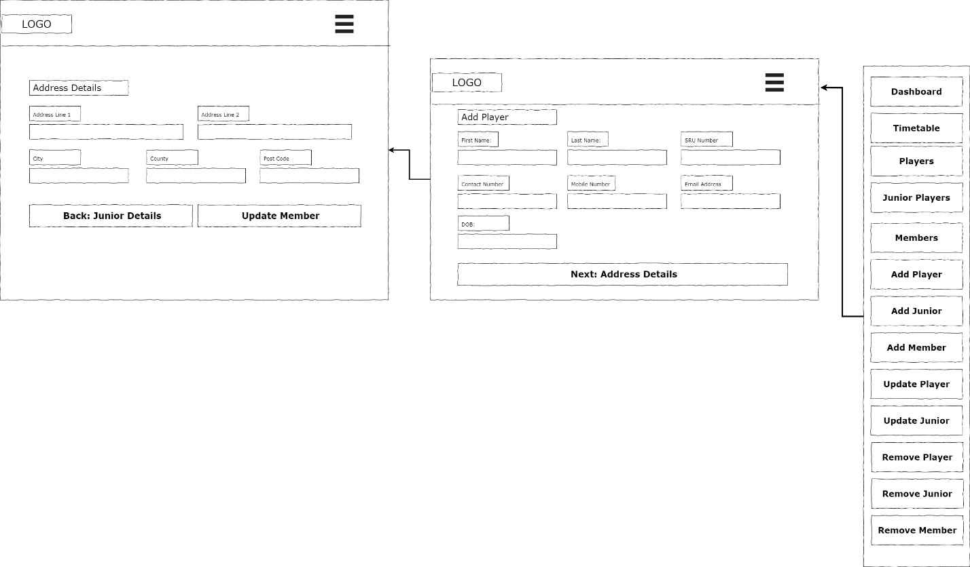

**Remove Player**

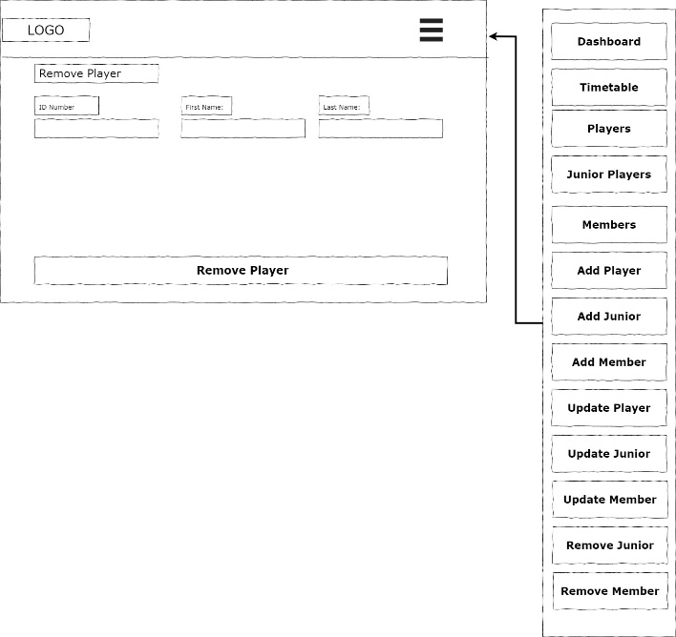

**Remove Junior**

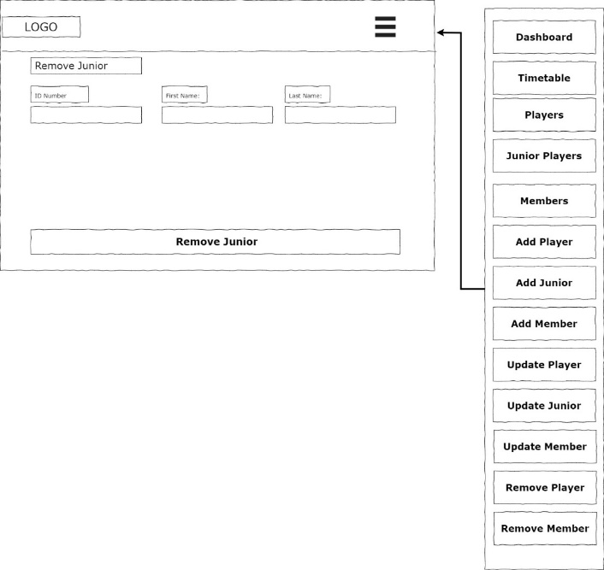

**Remove Member**

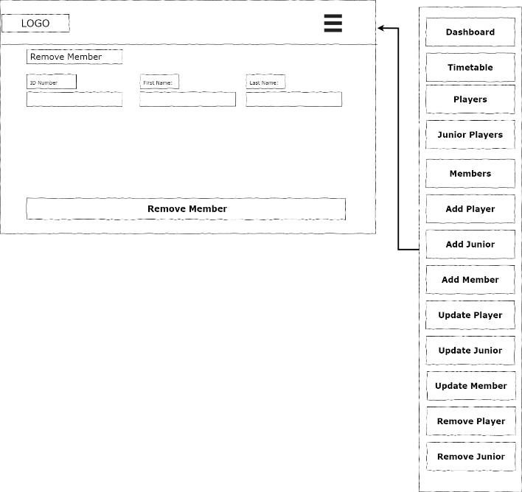

**Timetable**

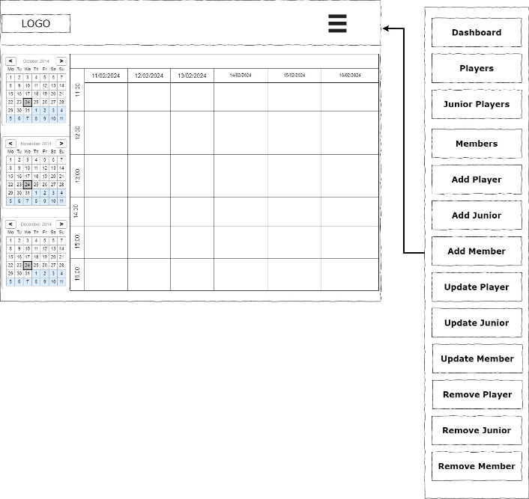

**Add Game/Session**

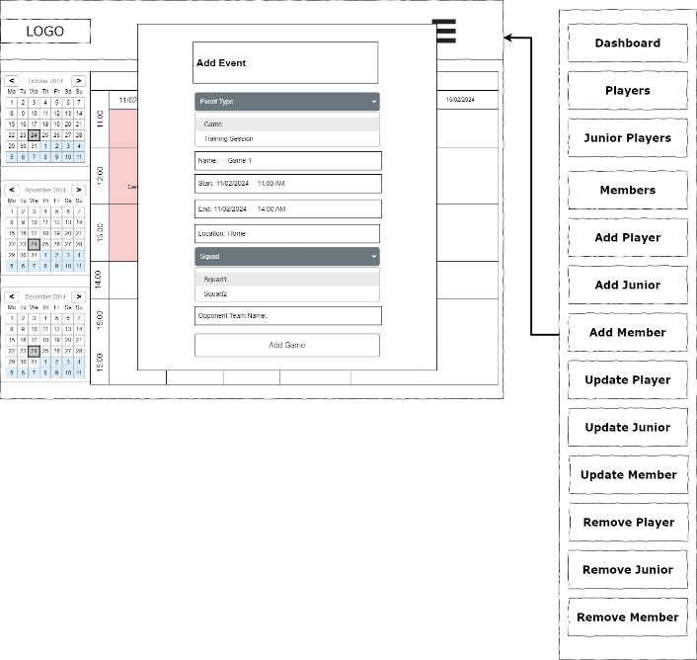

**Update Game/Session**

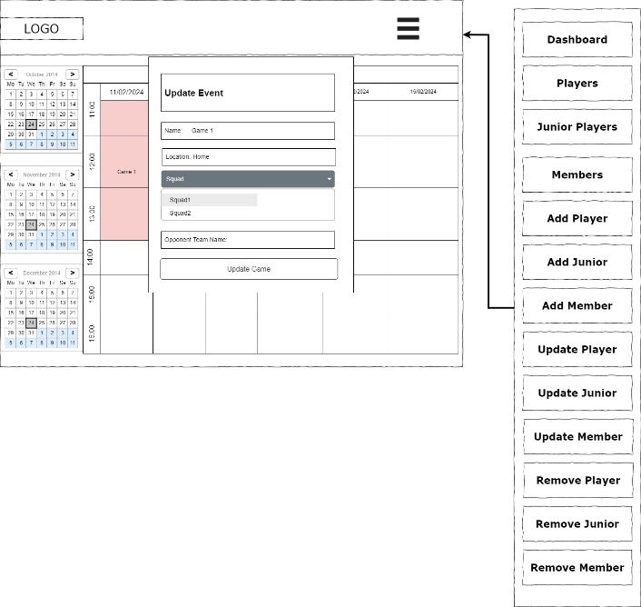

**Remove Game/Session**

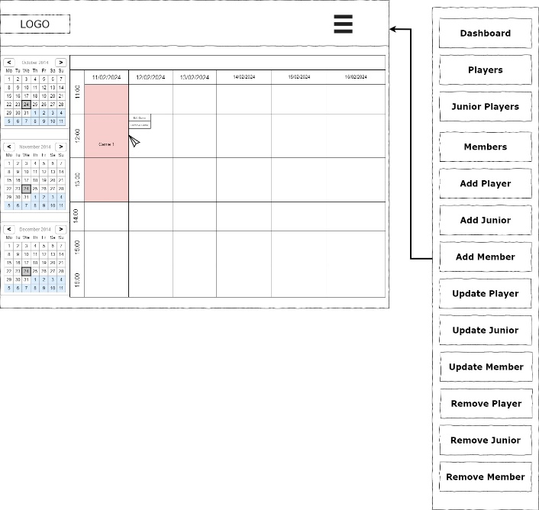

### View Model After

I have decided that the best way to show all updated view models is to just put a collection of screenshots from the actual finished product.

**Dashboard**

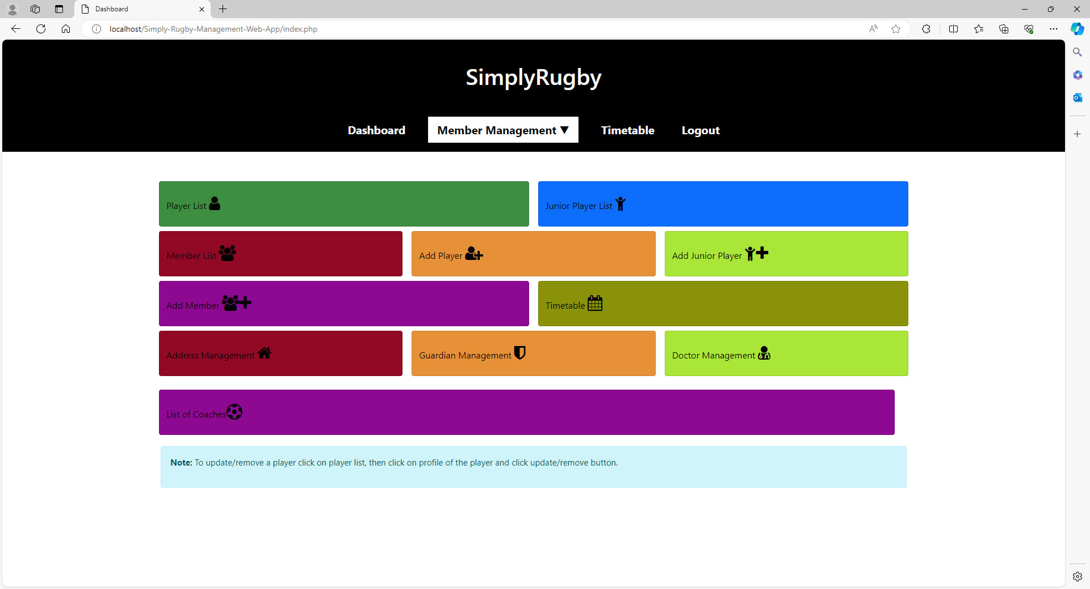

**Add Player**

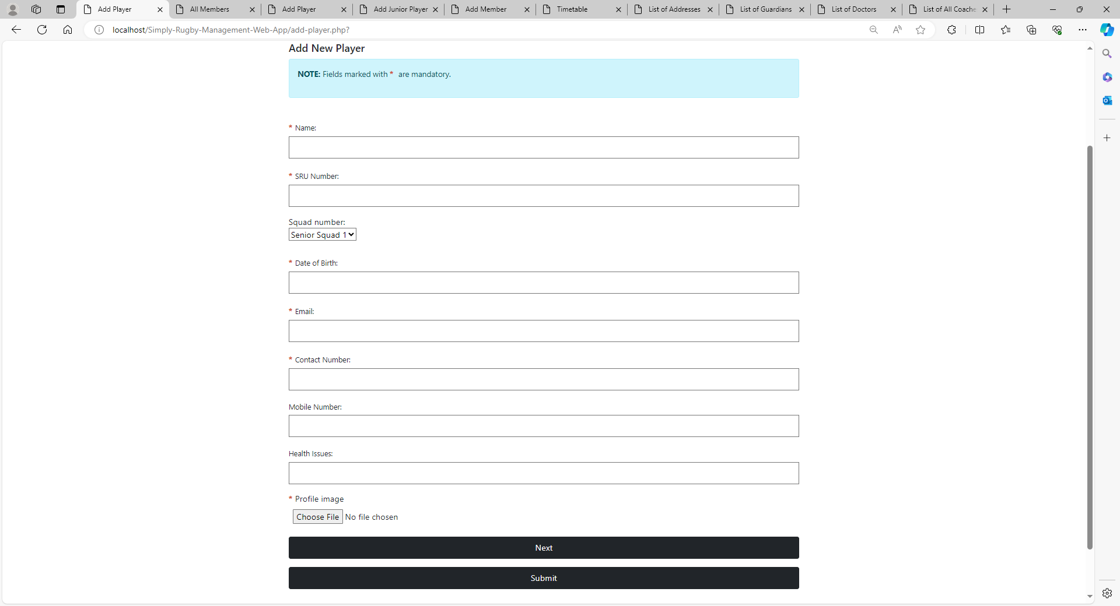

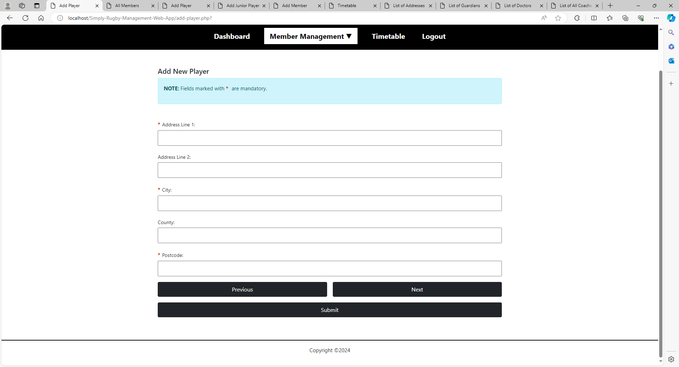

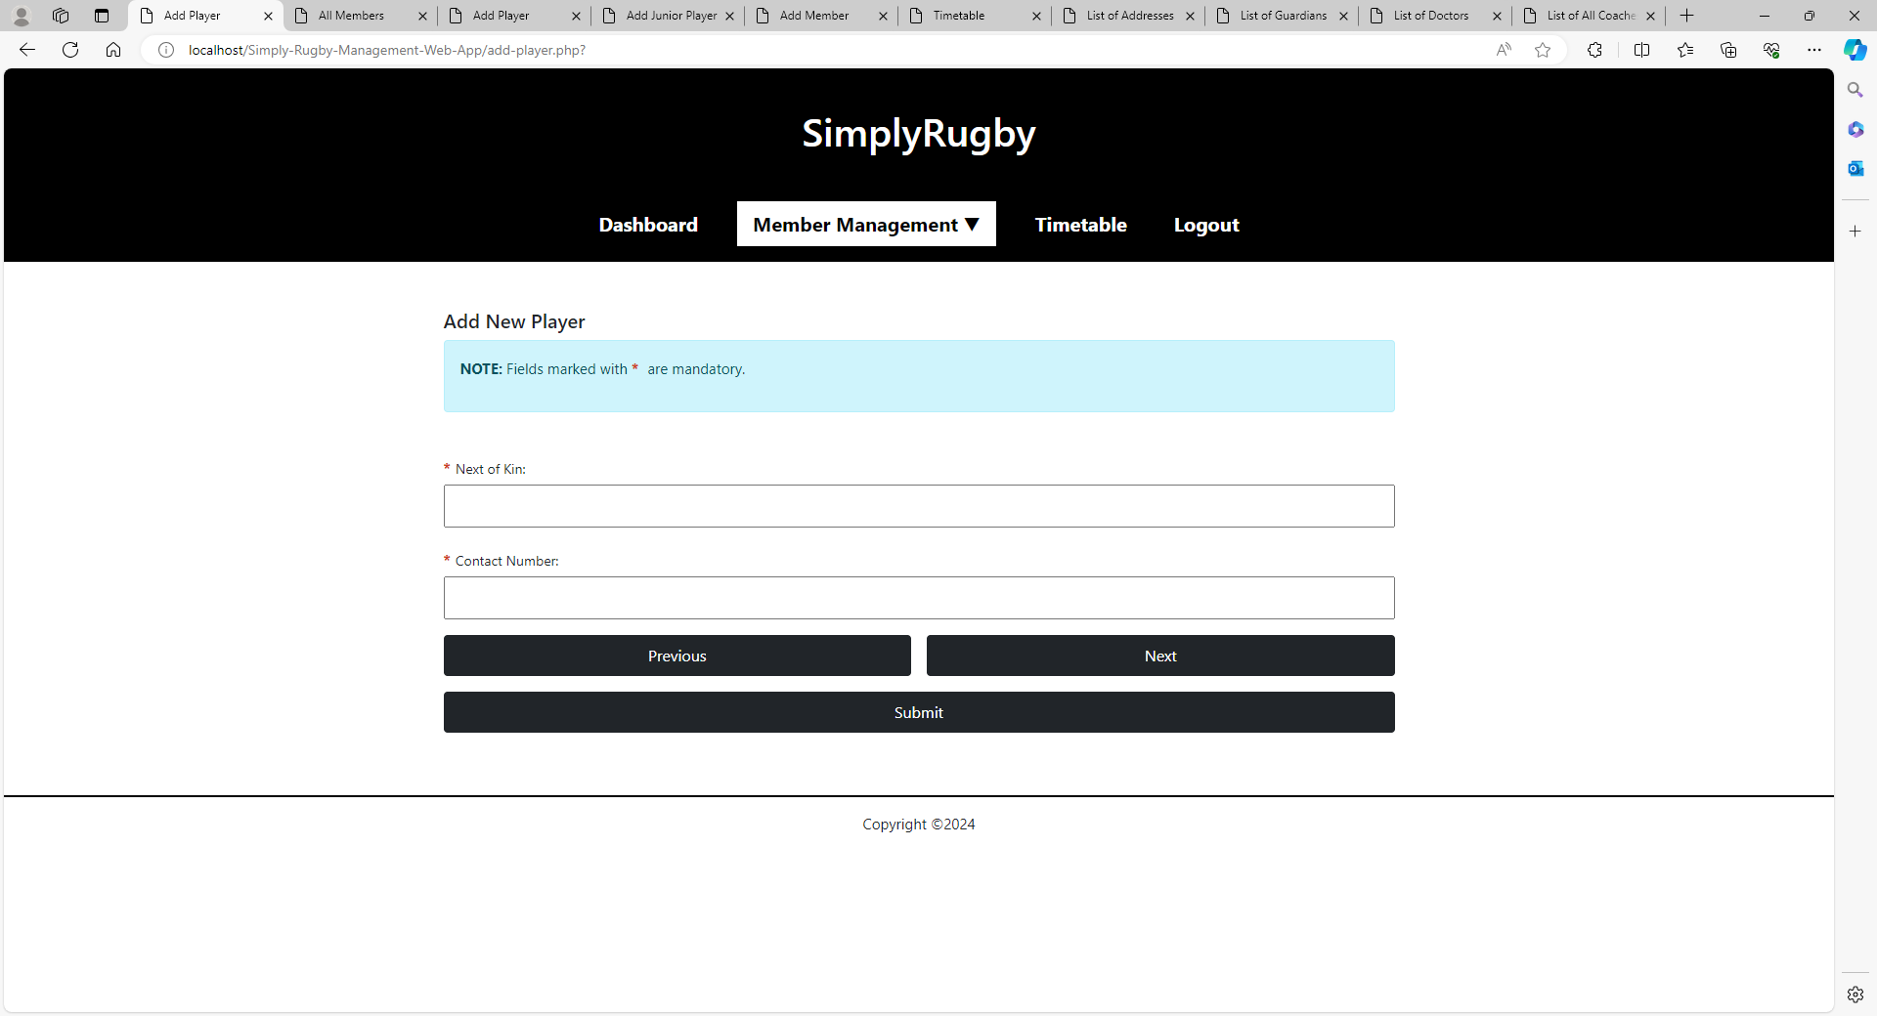

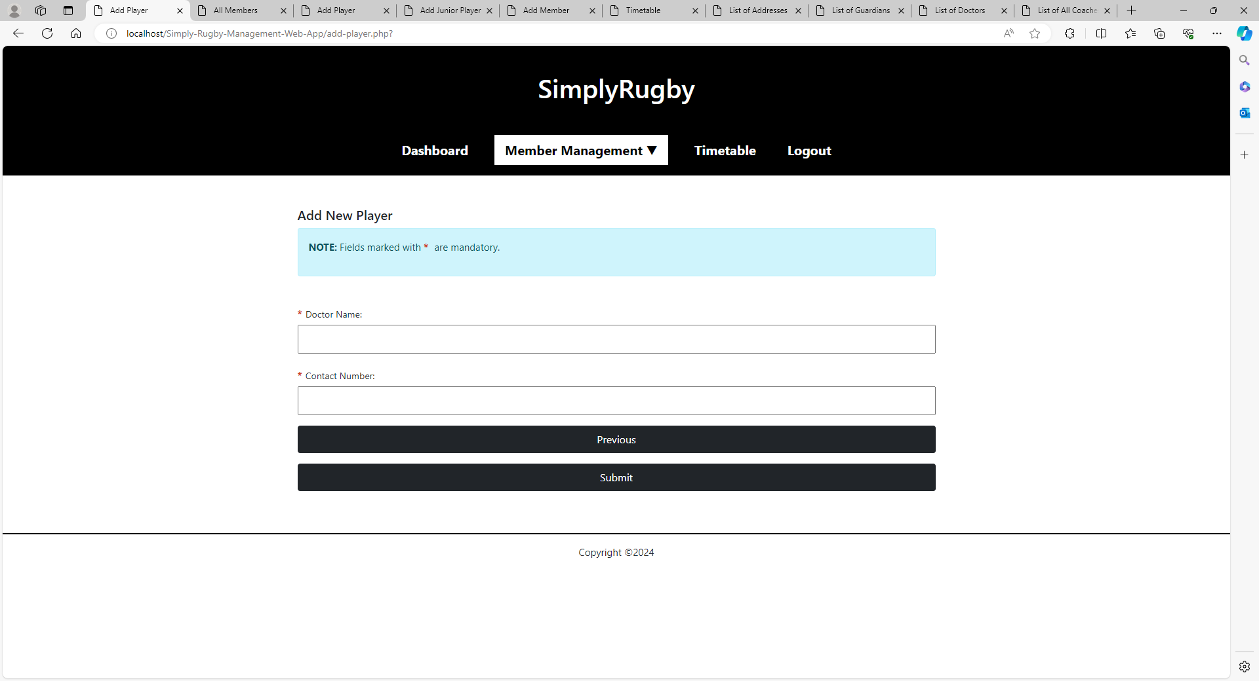

**Player / Junior / Member List**

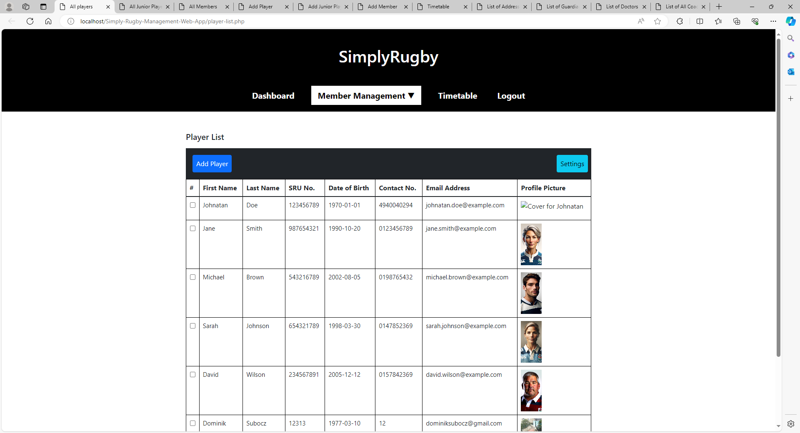

**Update Player**

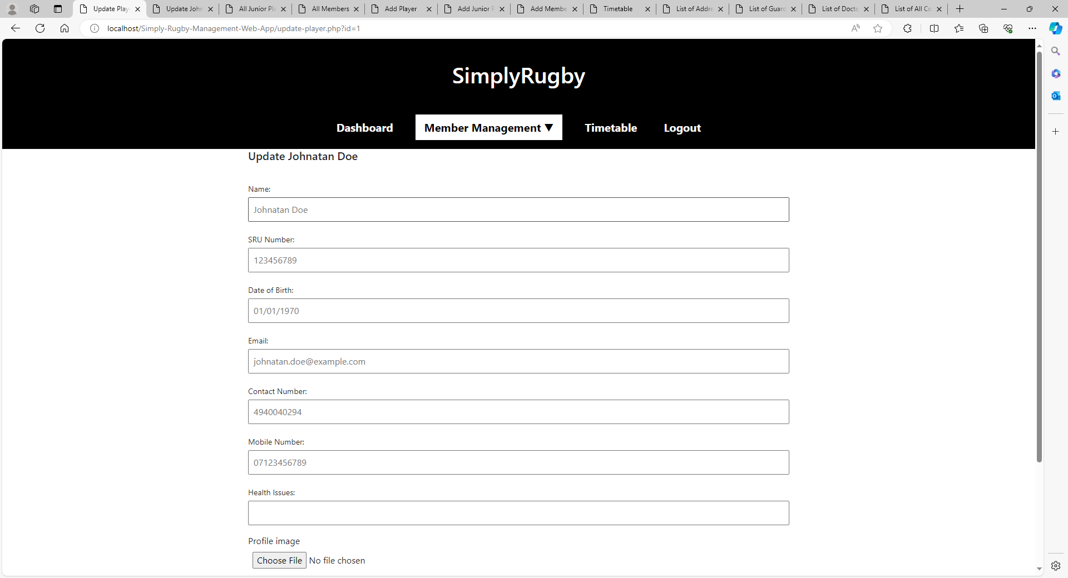

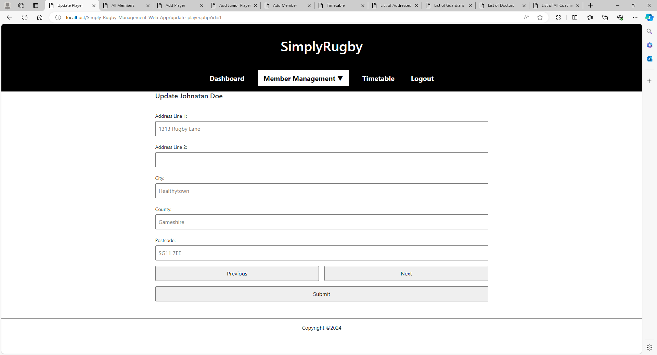

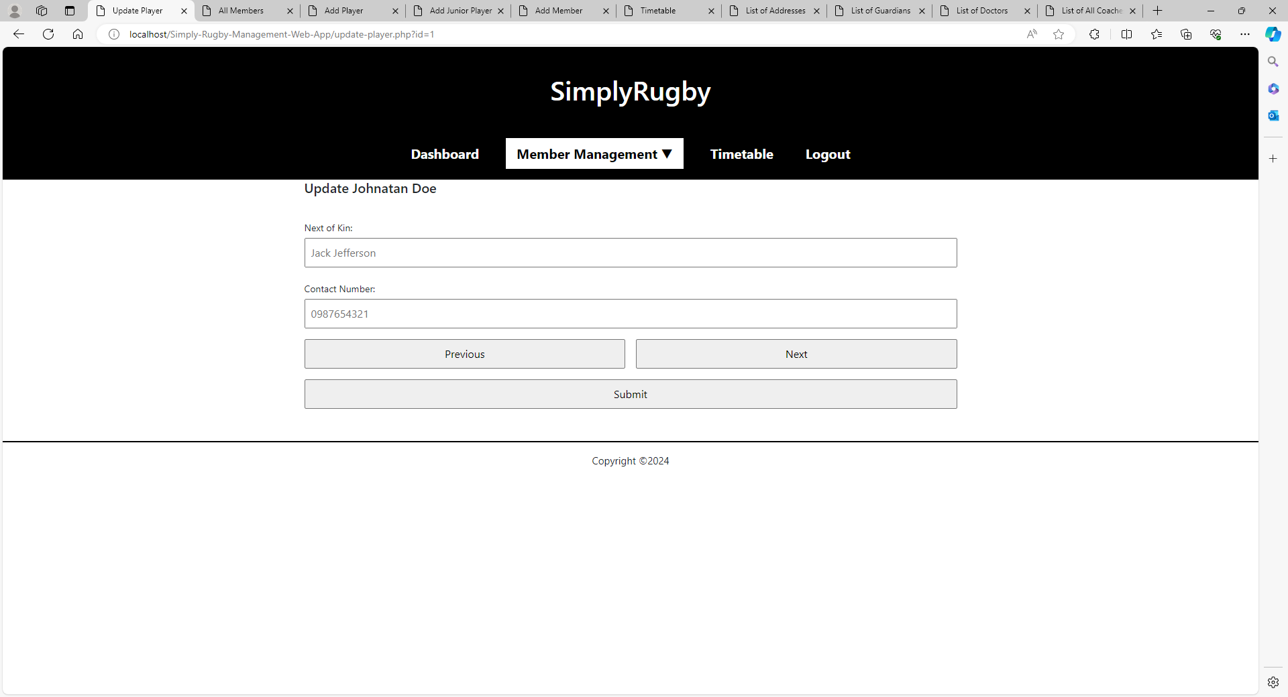

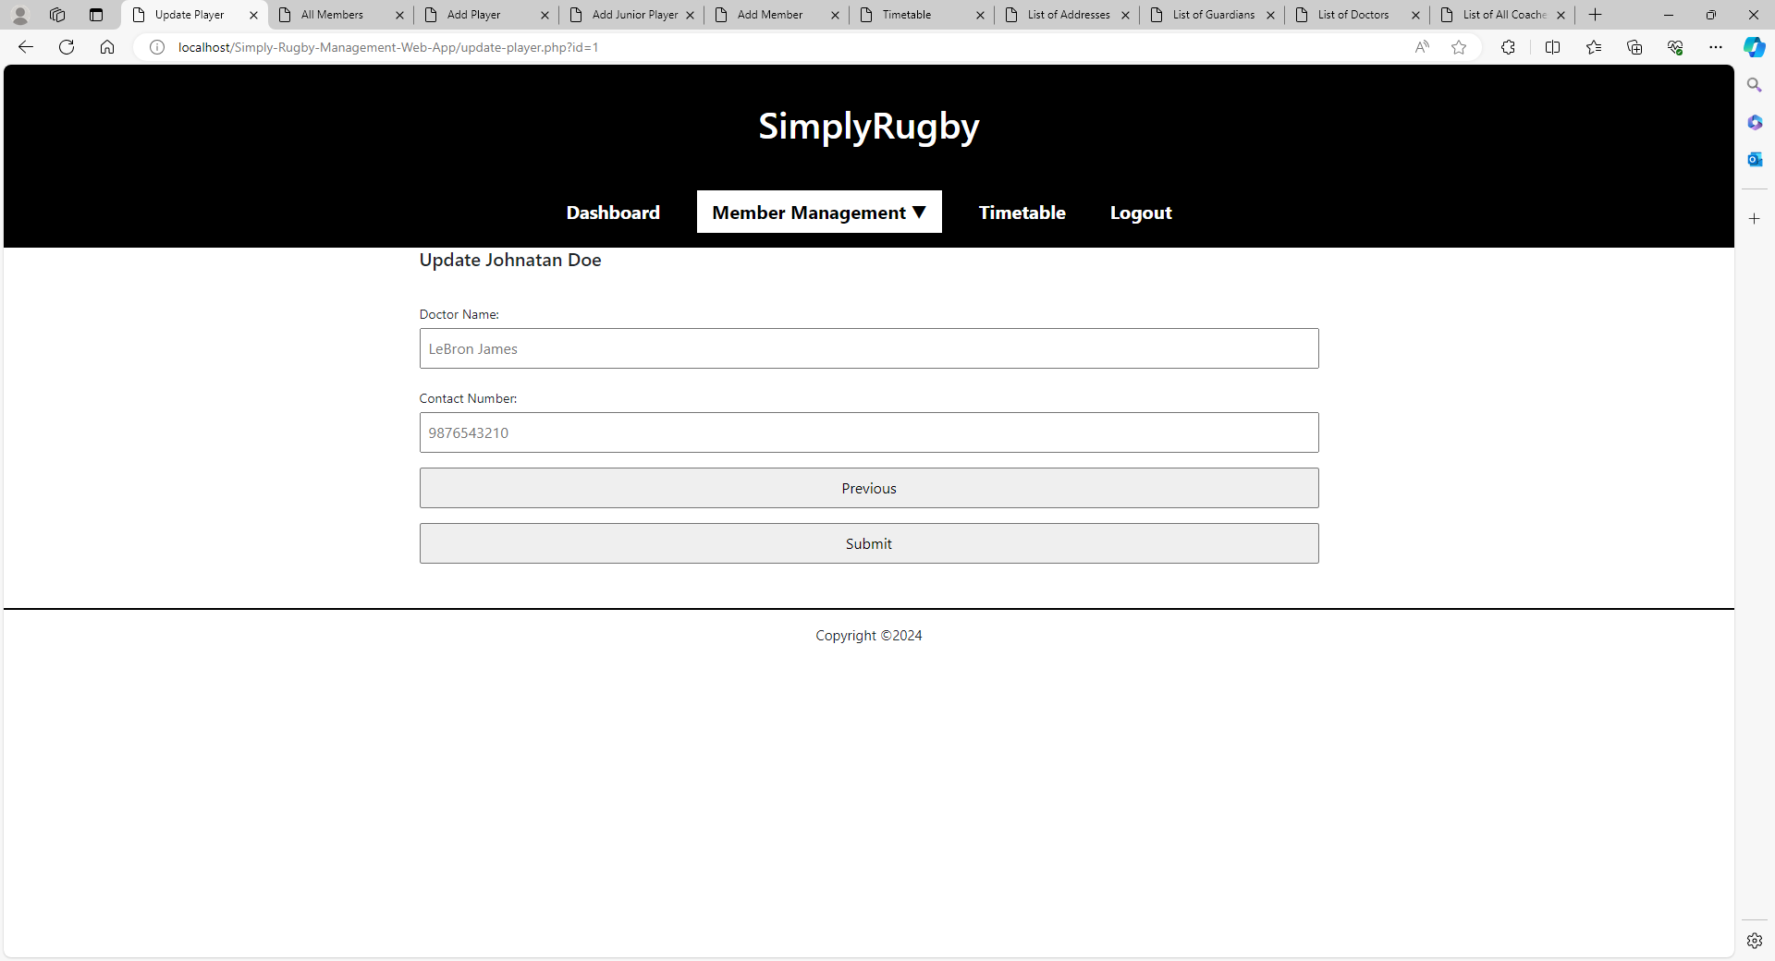

**Update Player Skills**

This page looks identical for junior players, so I won’t put it up to avoid duplication.

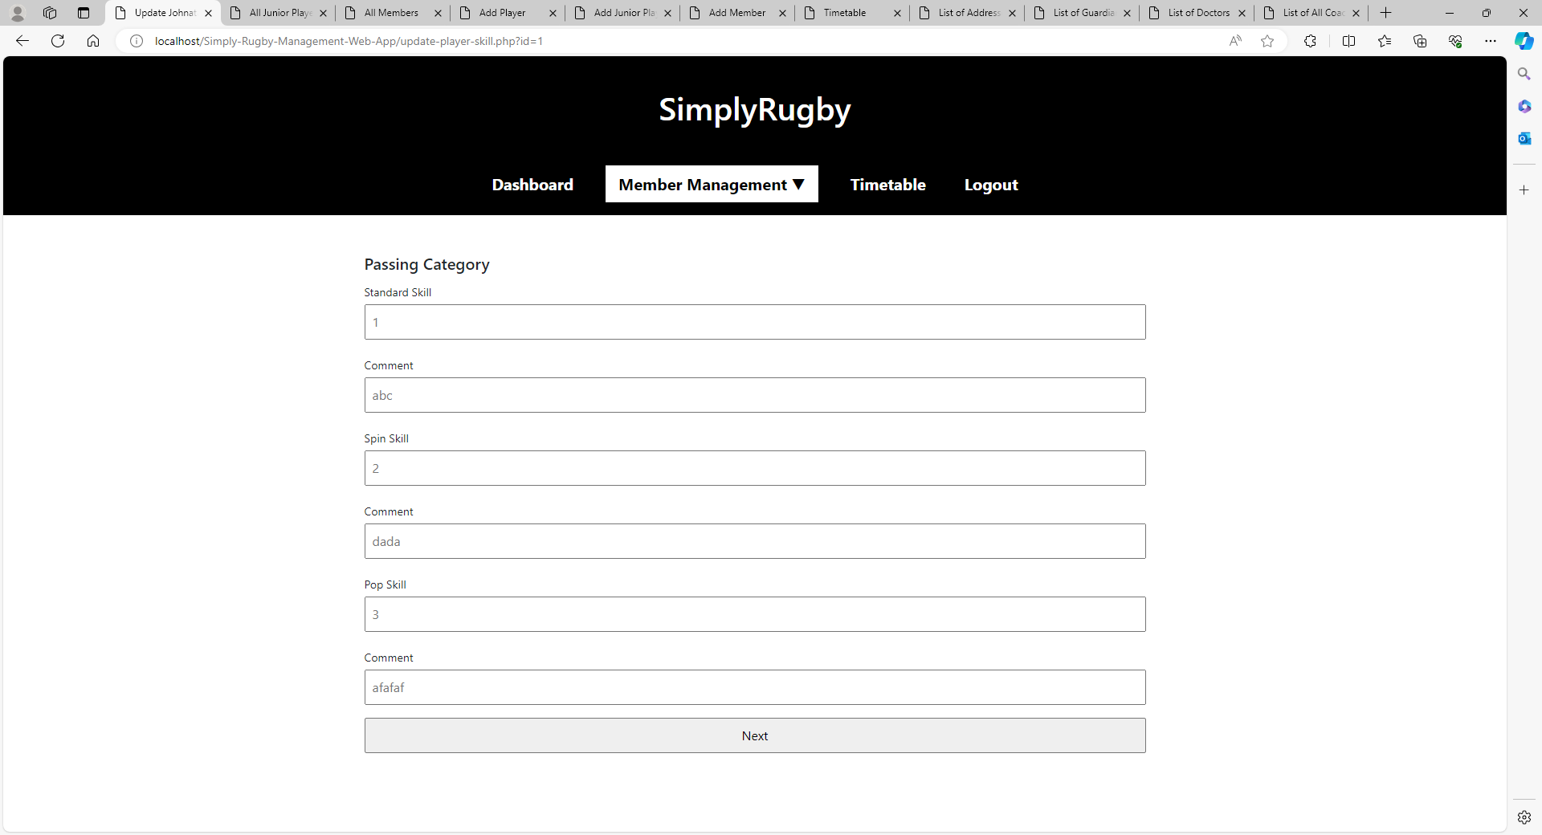

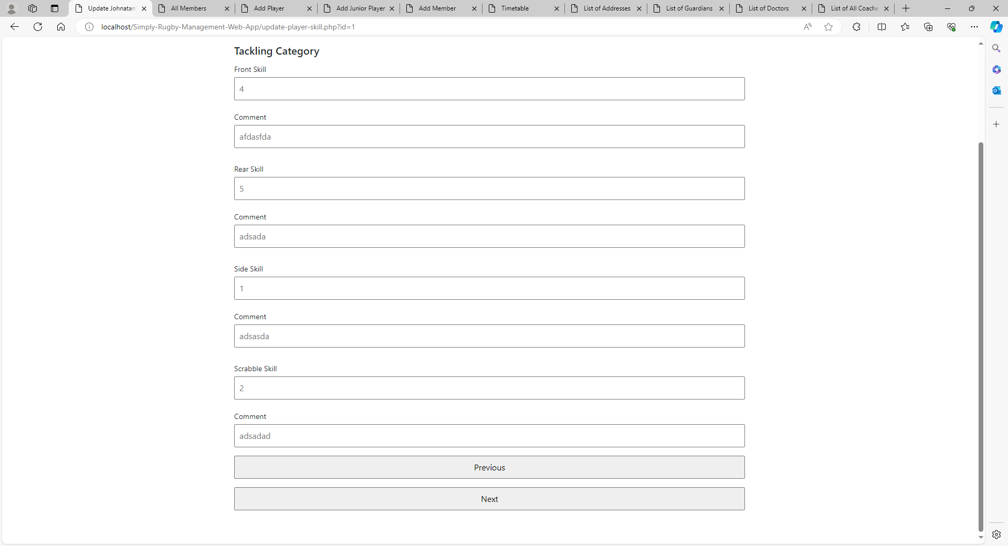

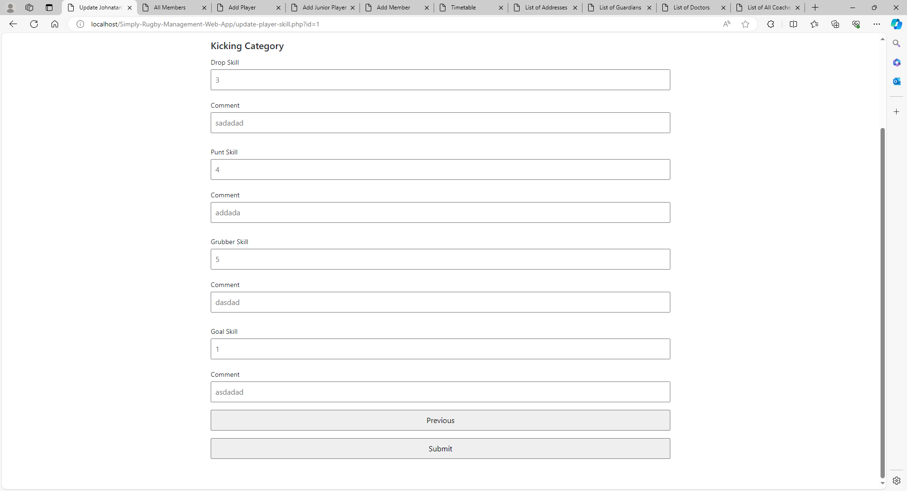

**Add Junior Player**

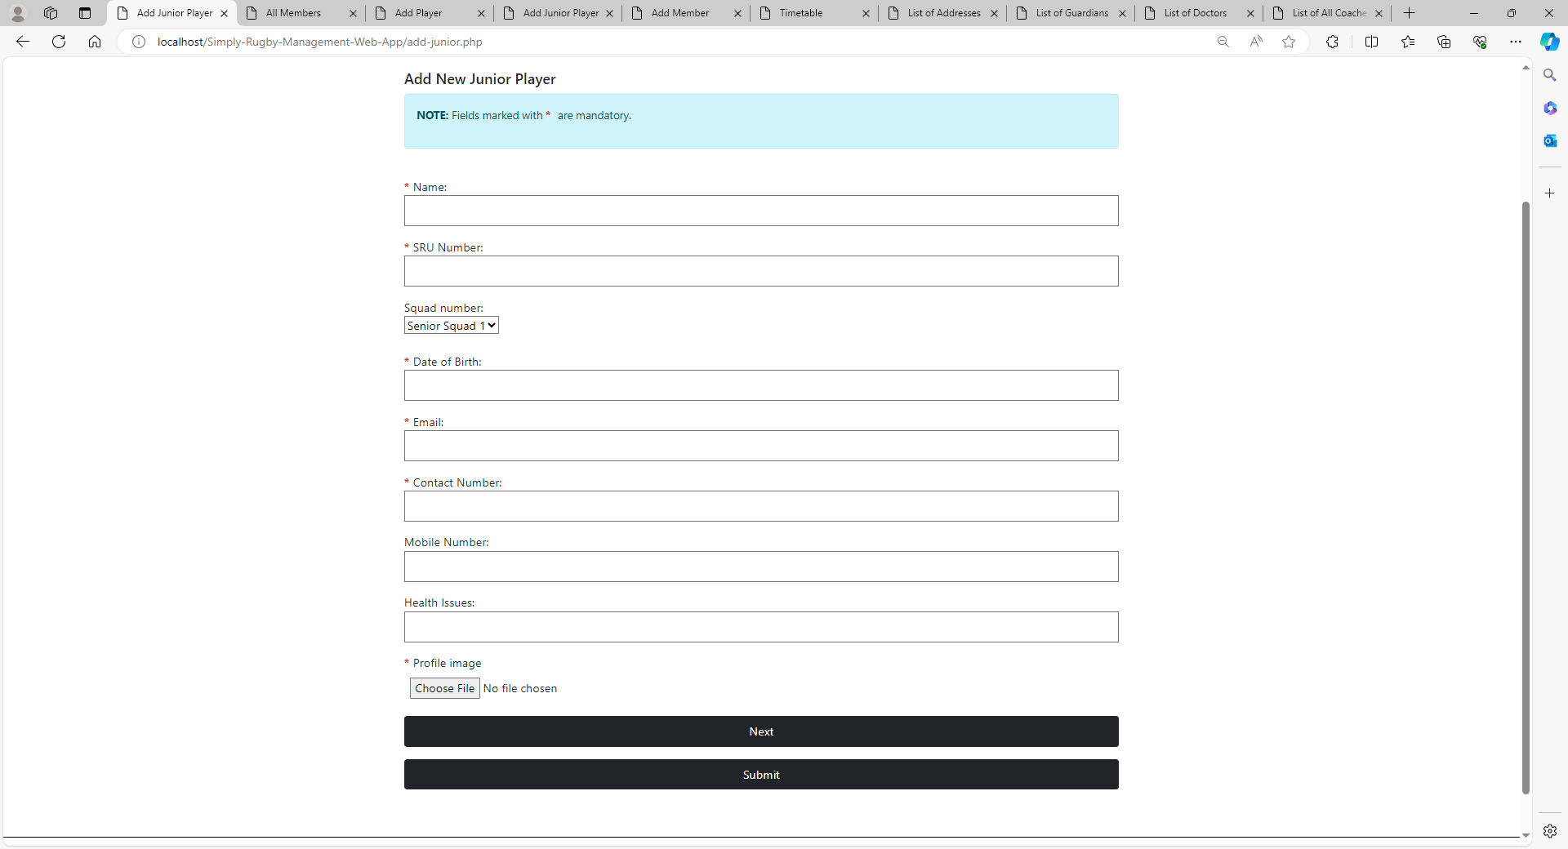

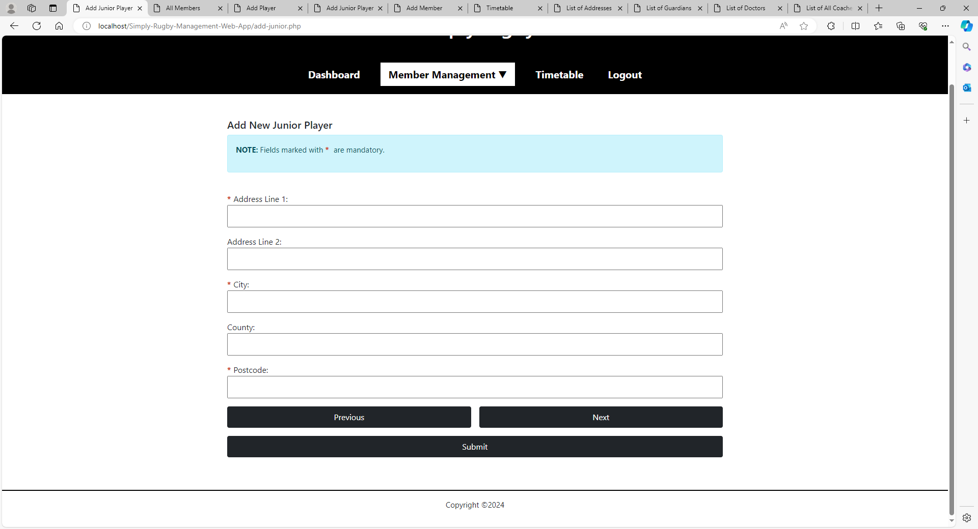

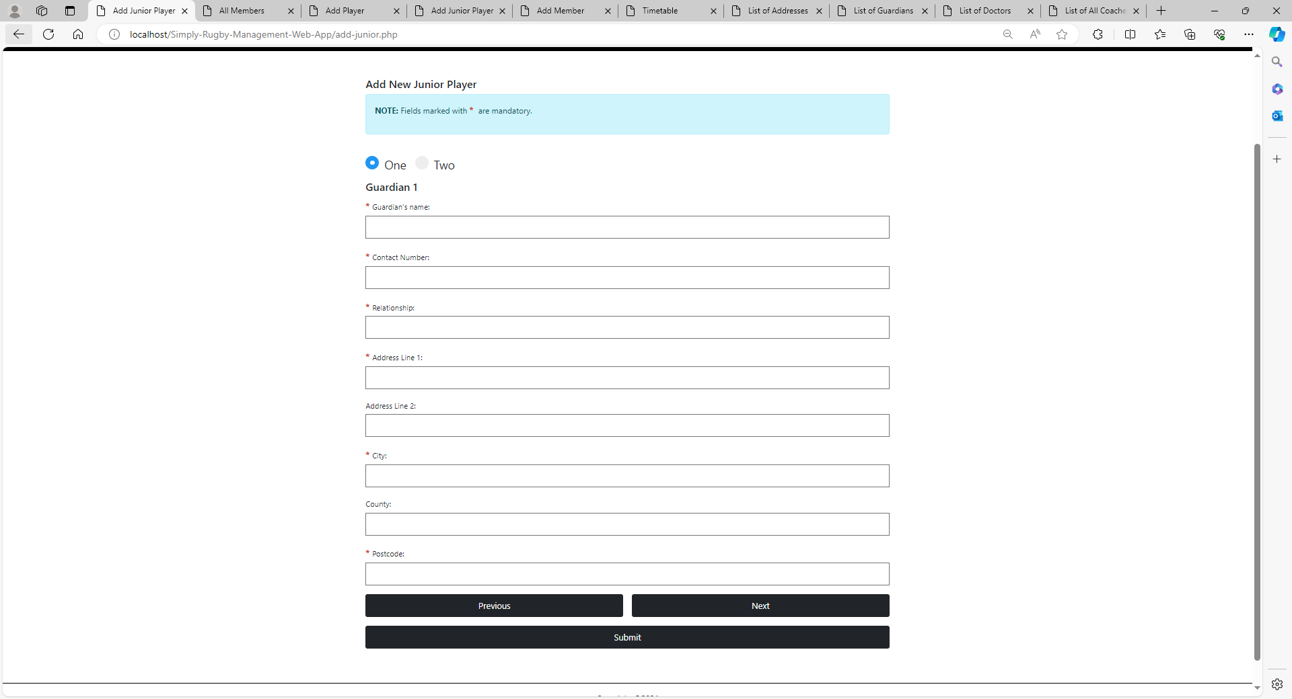

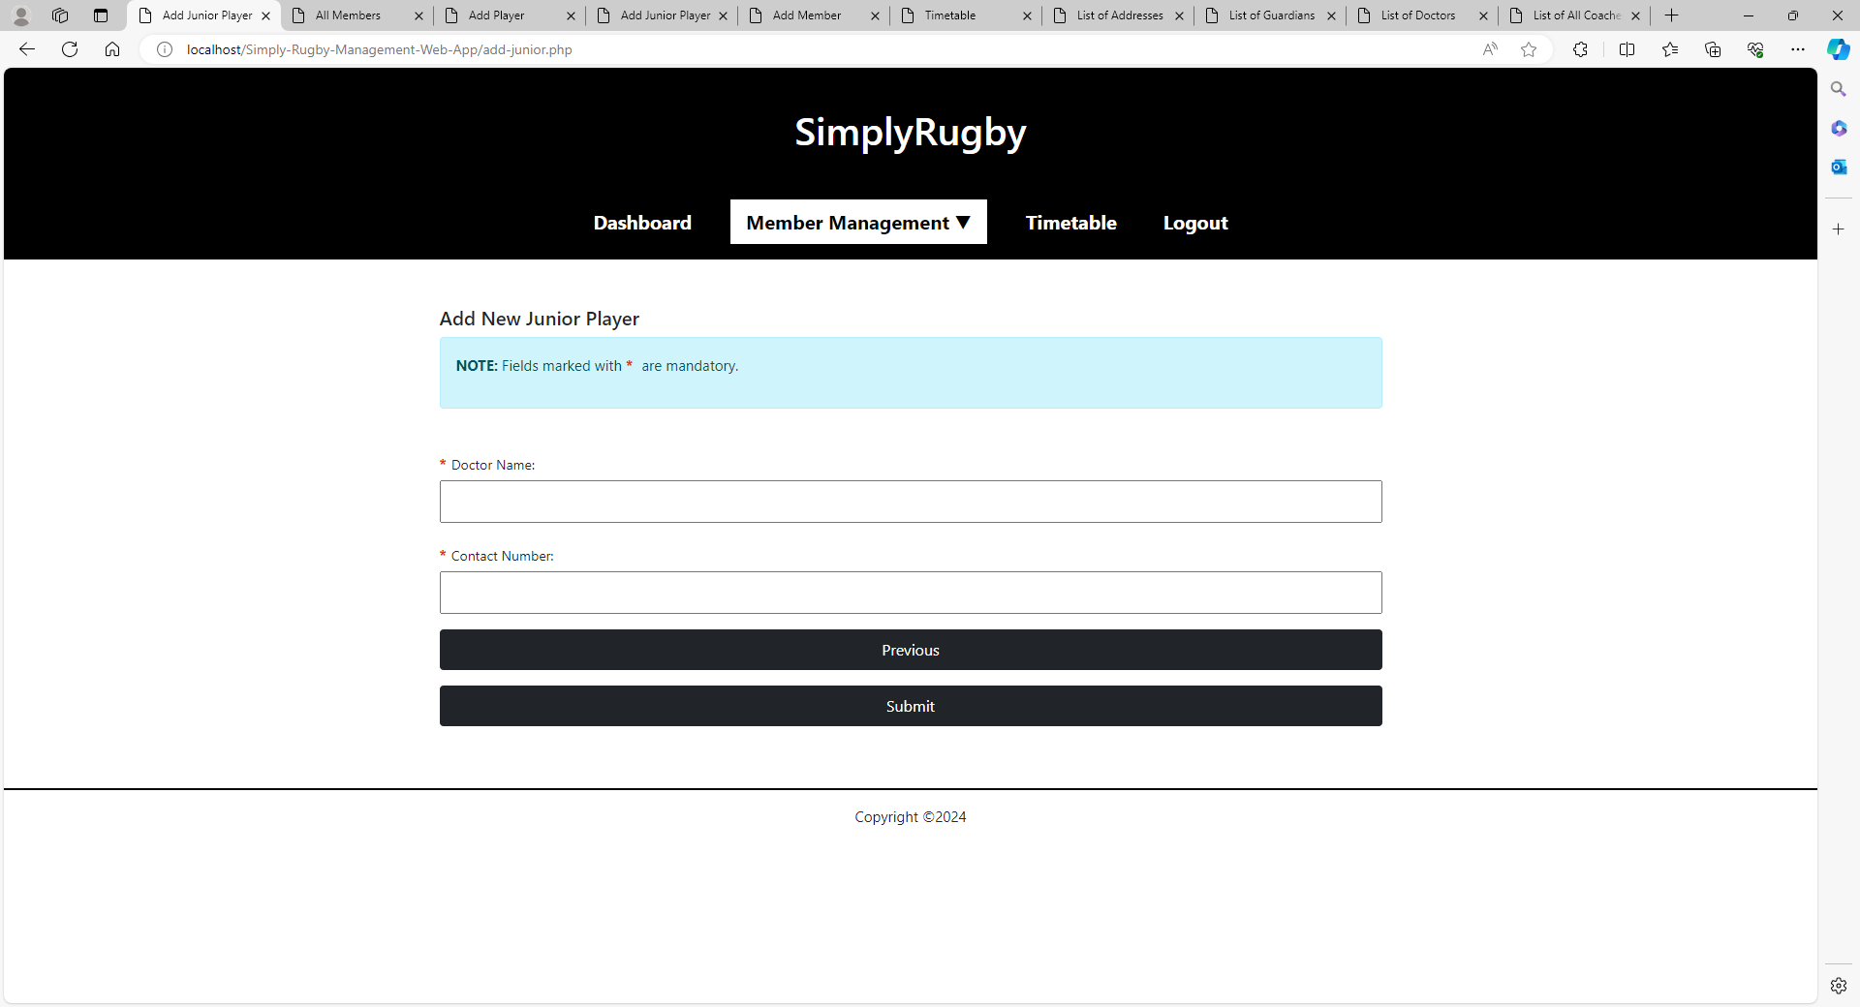

**Update Junior Player**

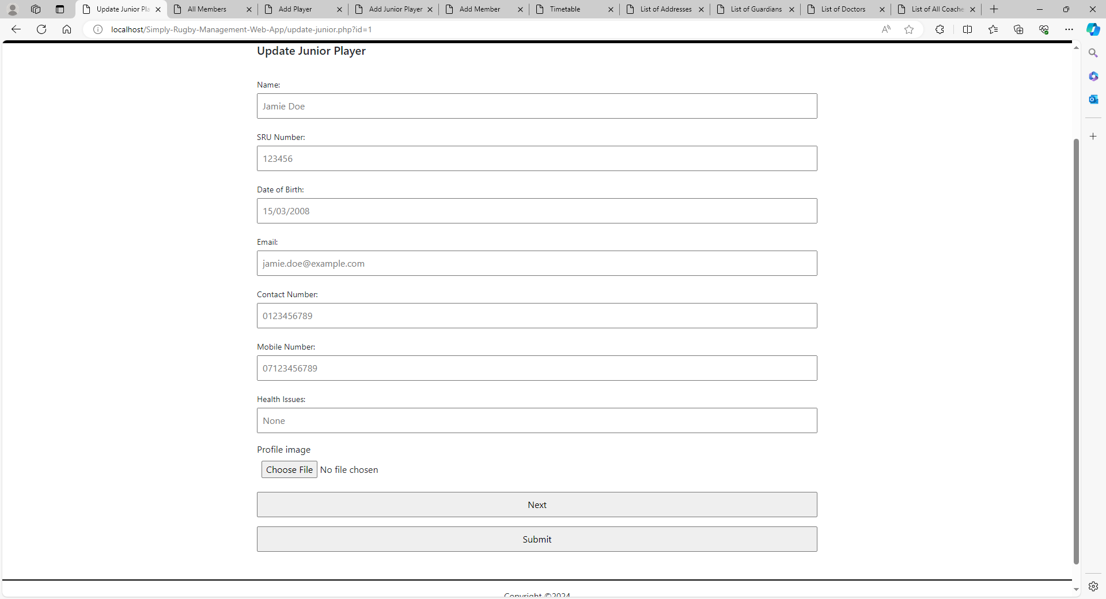

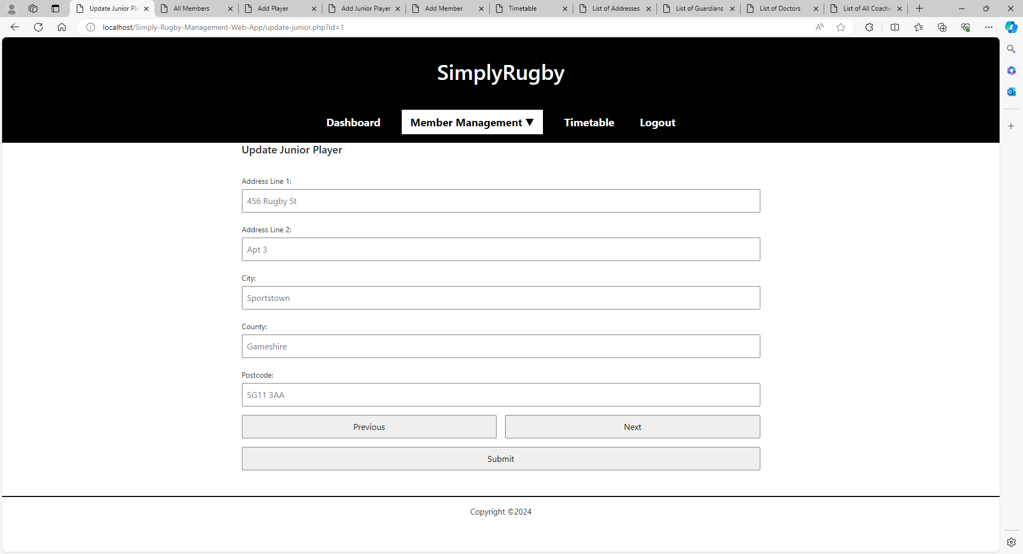

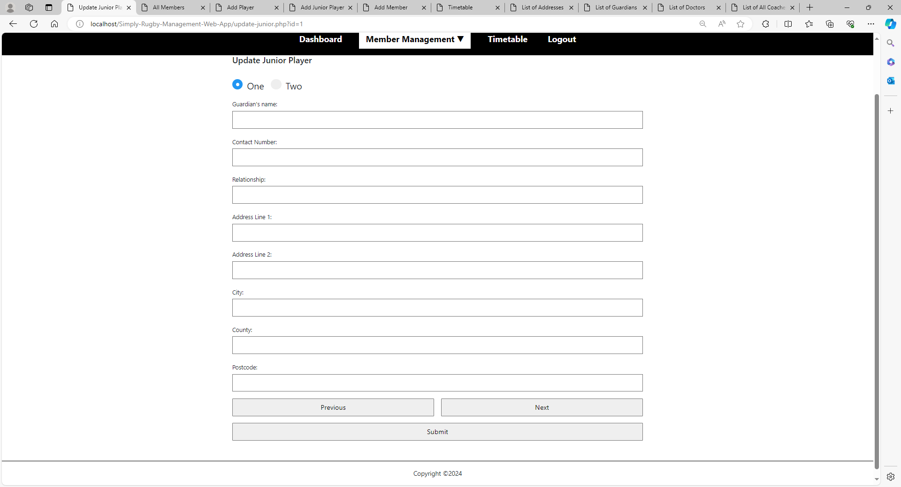

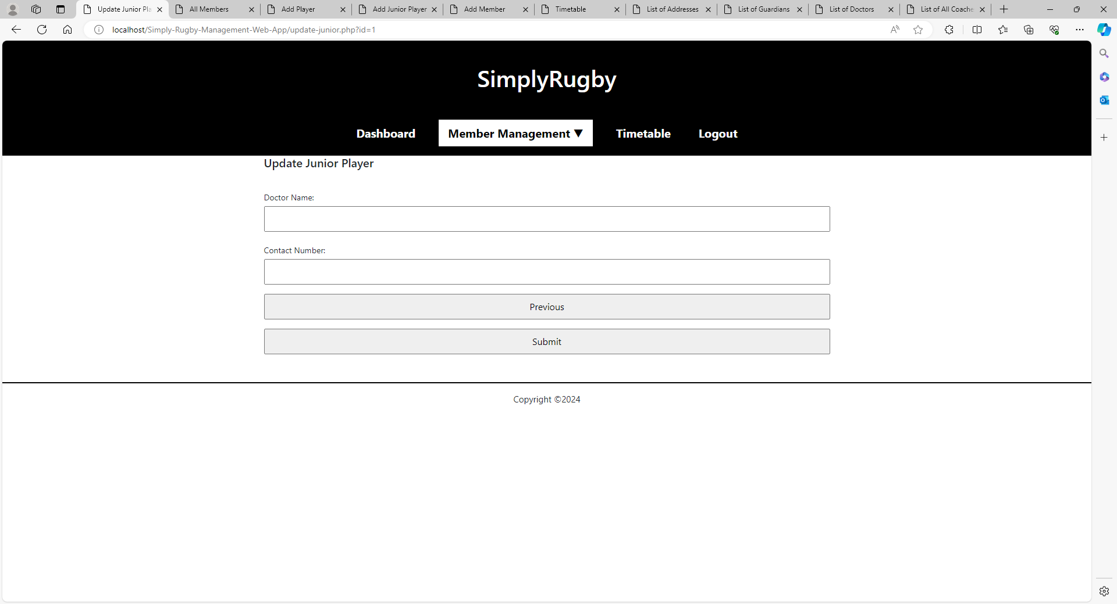

**Add Member**

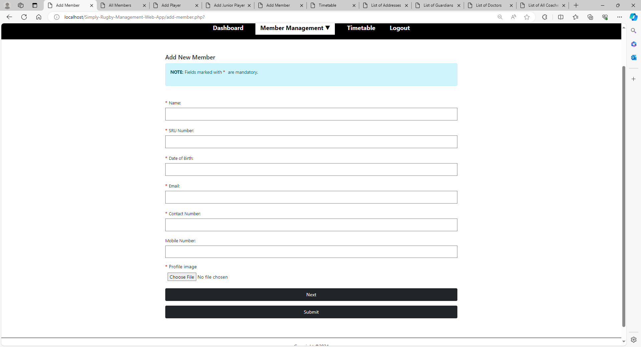

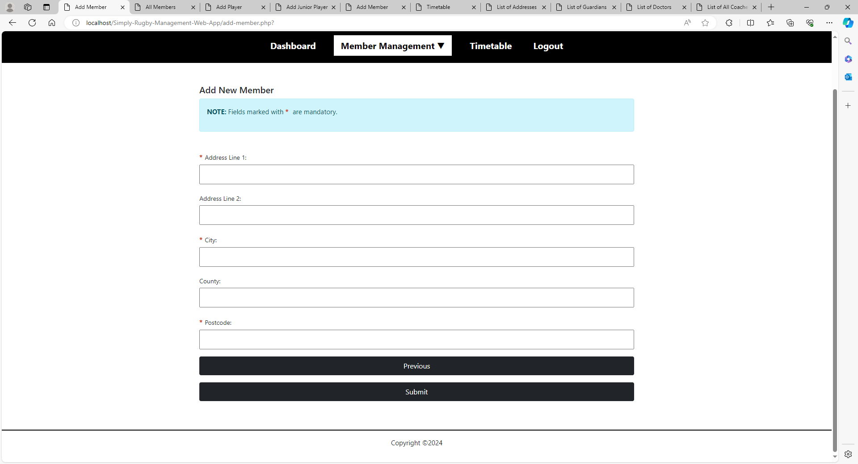

**Update Member**

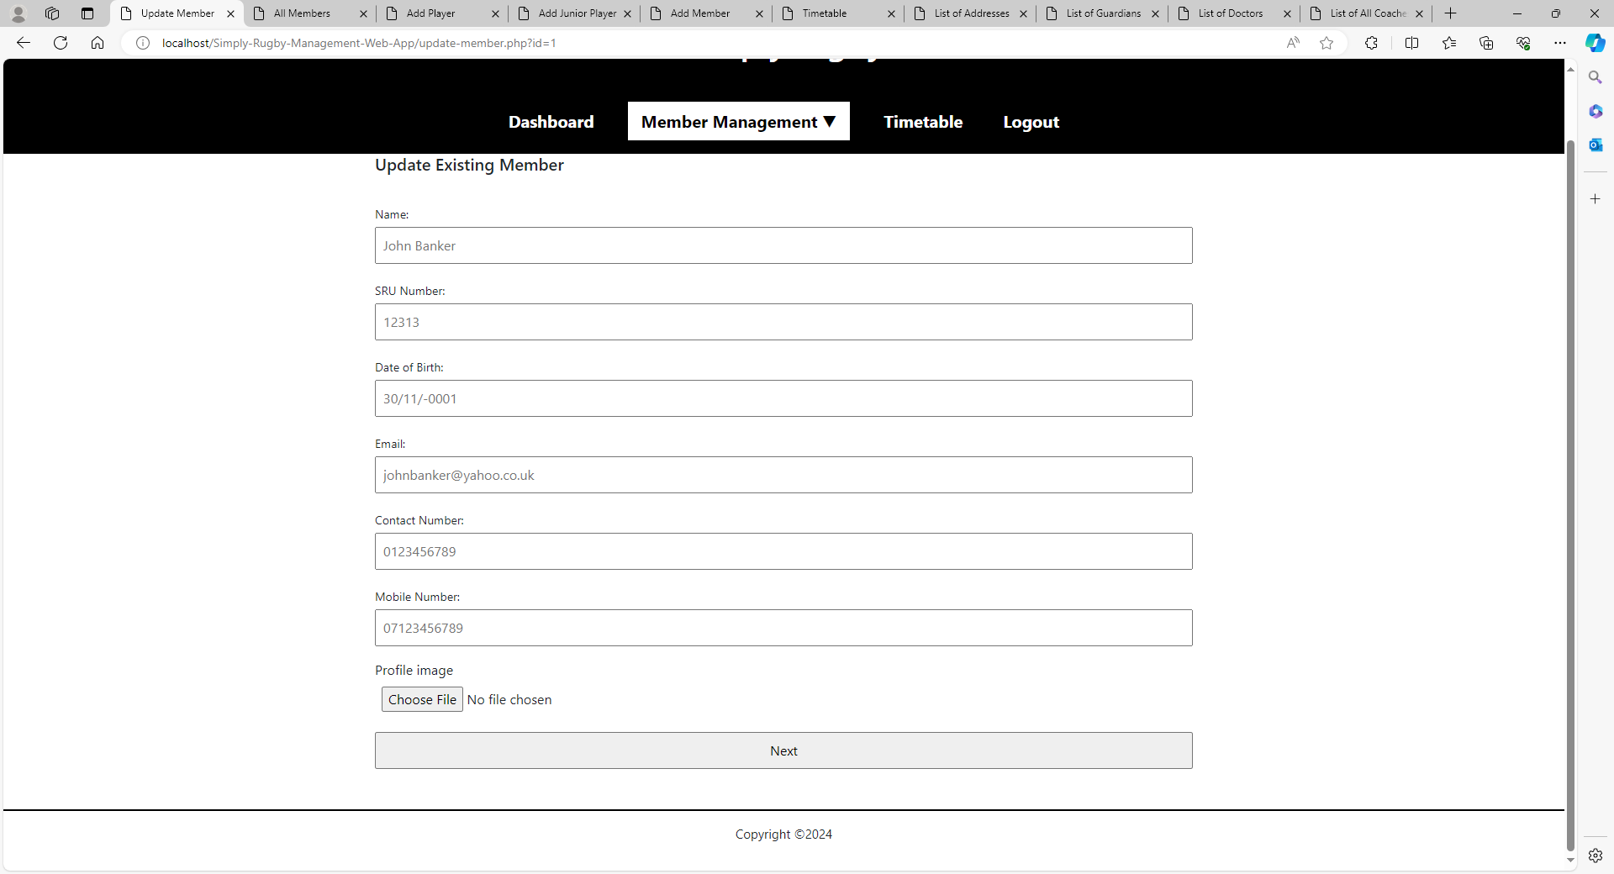

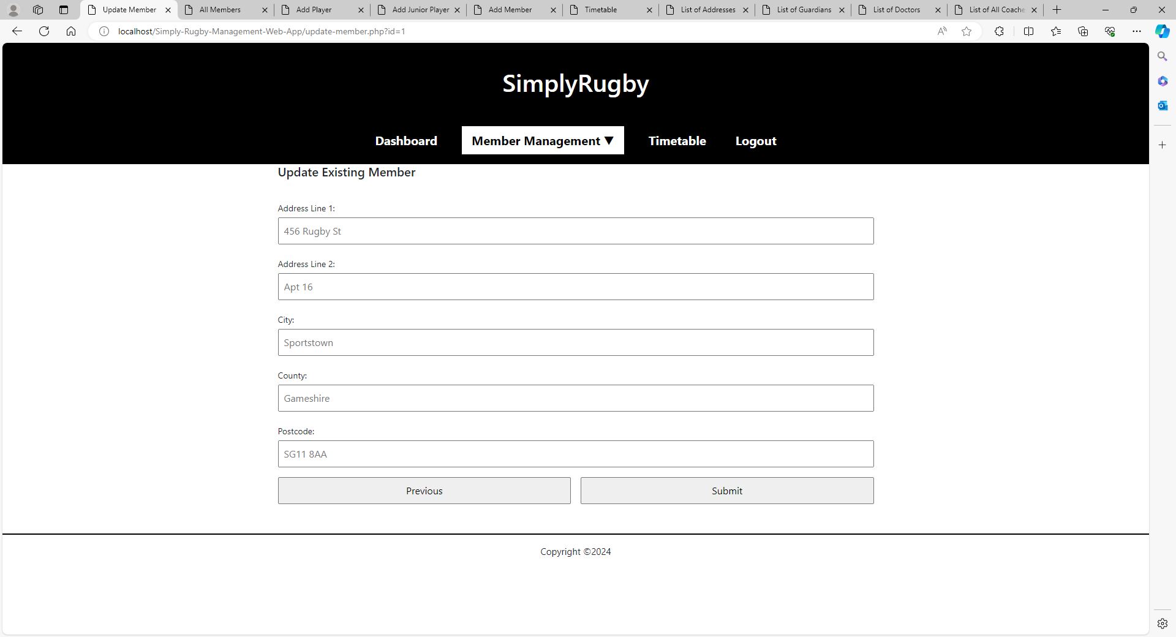

**Timetable**

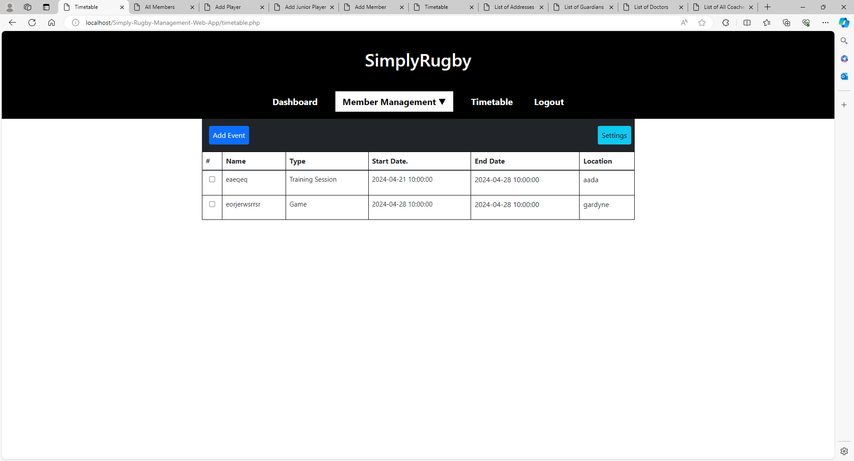

**Add Event**

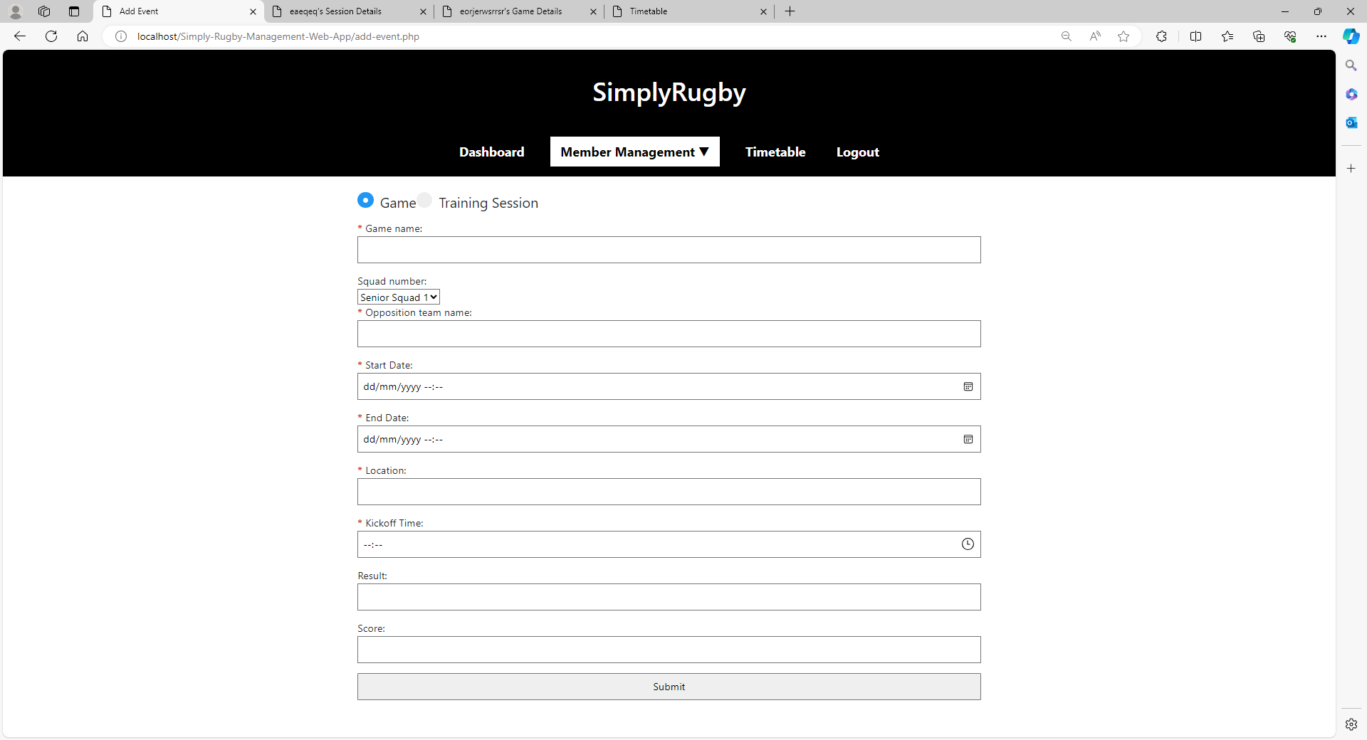

**Training Session Profile**

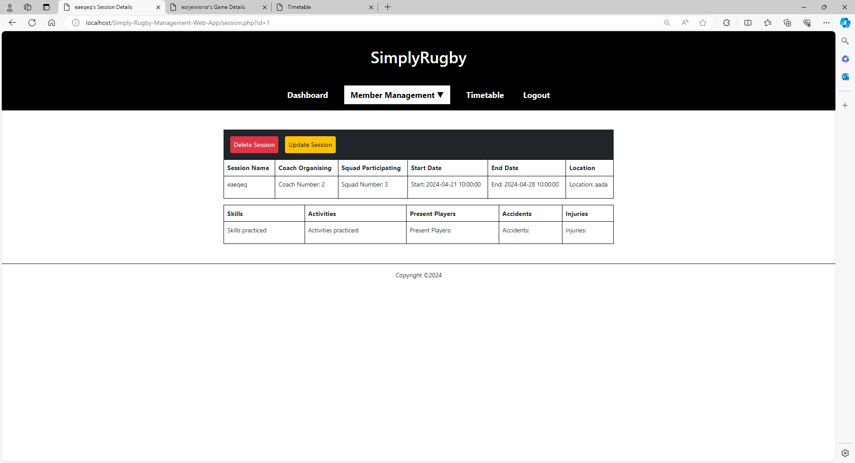

**Game Profile**

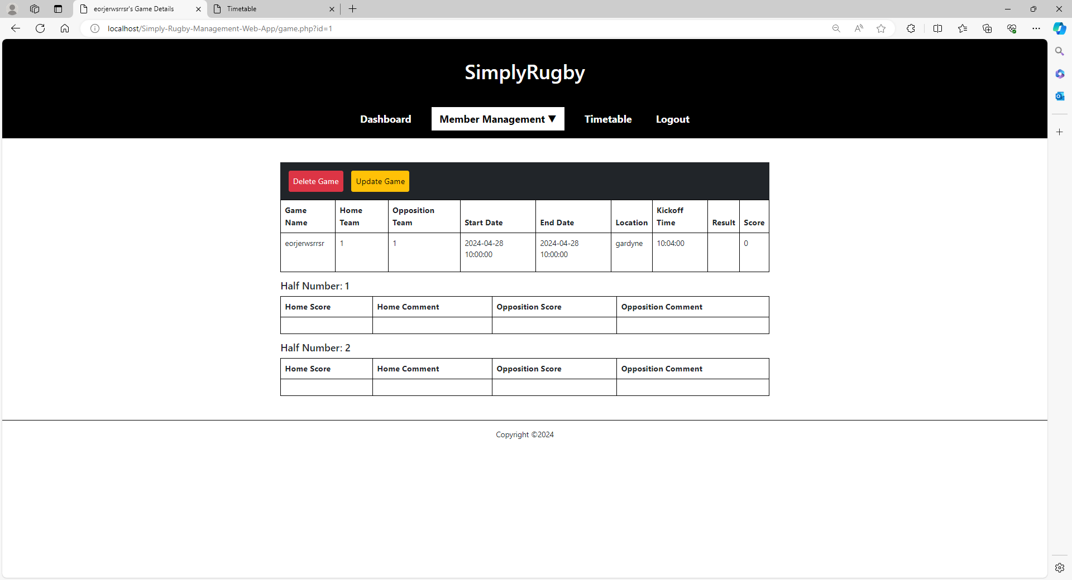

**Success Page**

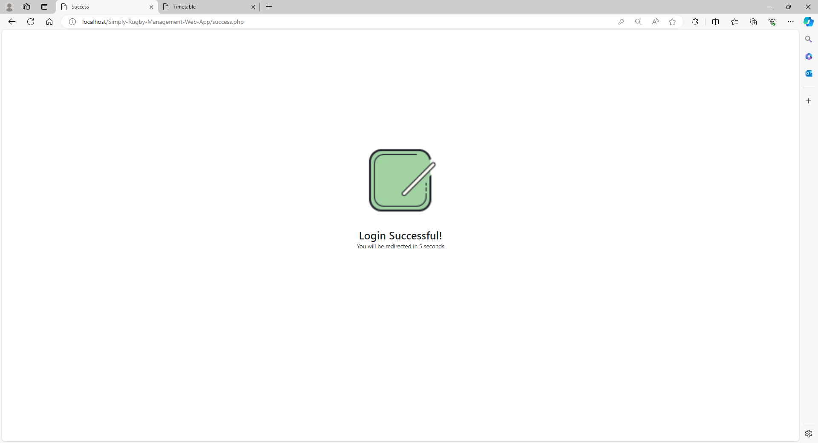

**Address-List**

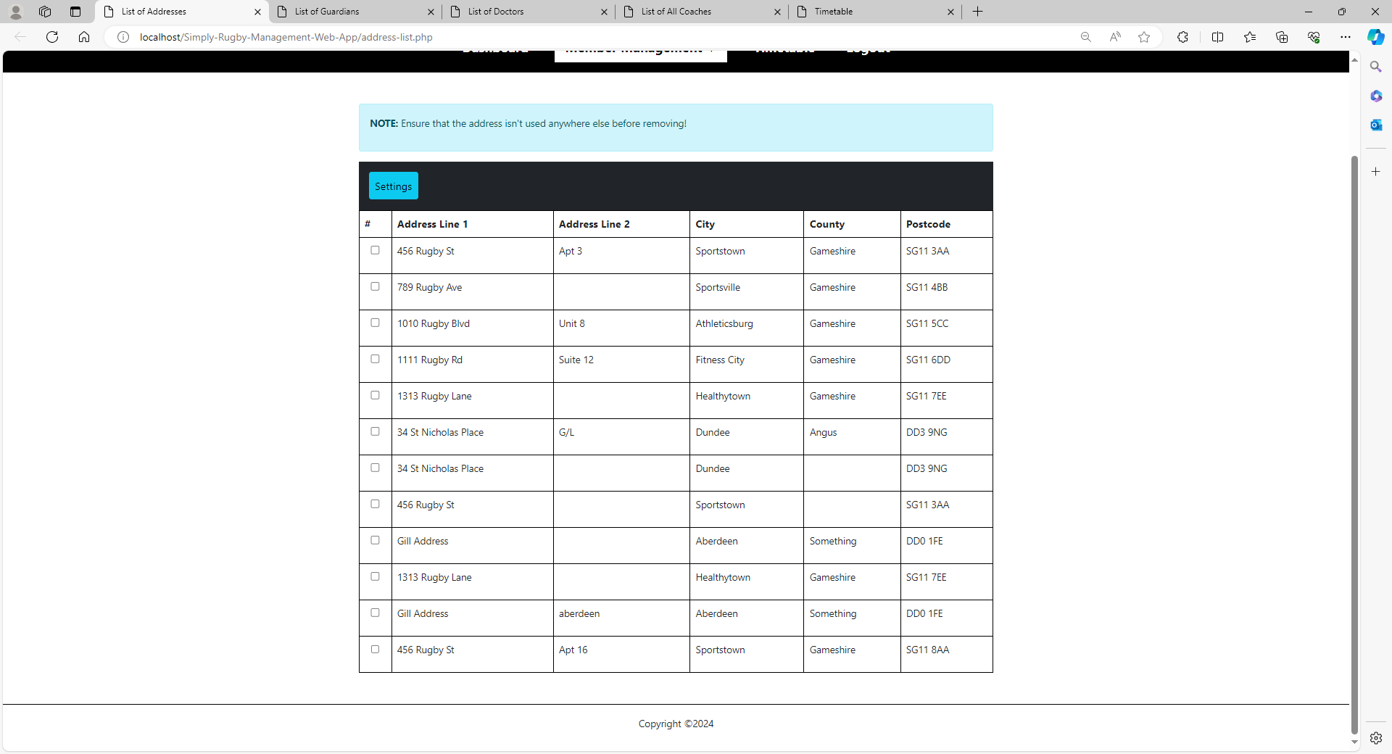

**Guardian List**

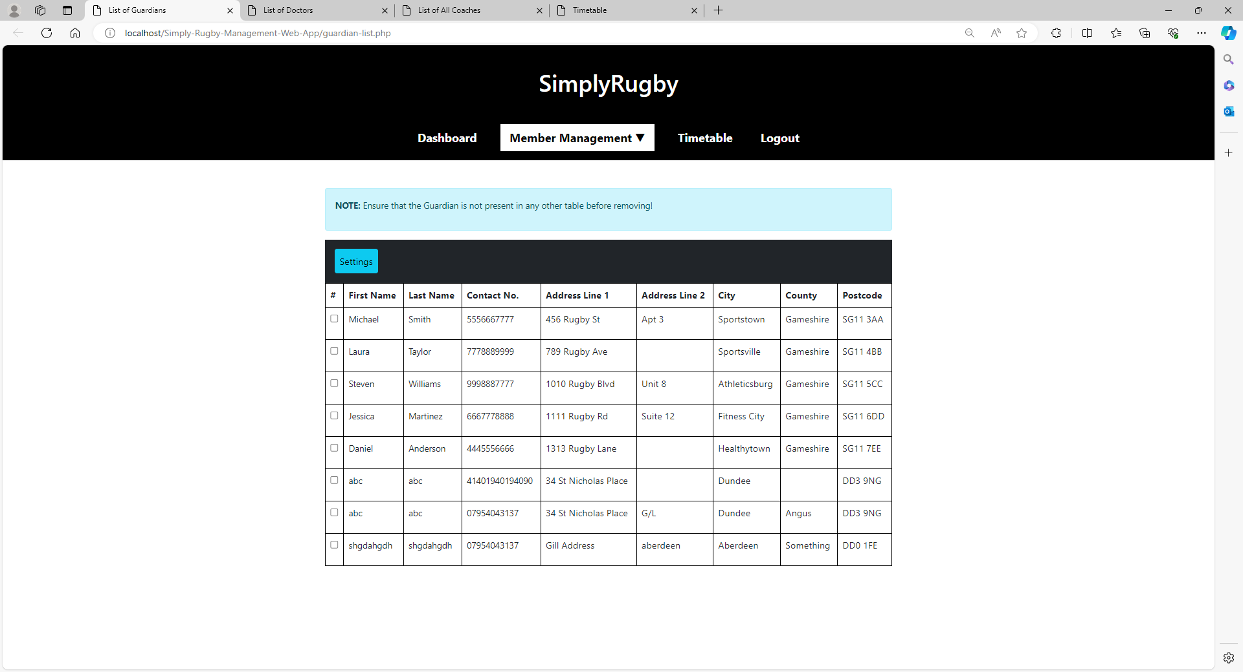

**Doctor List**

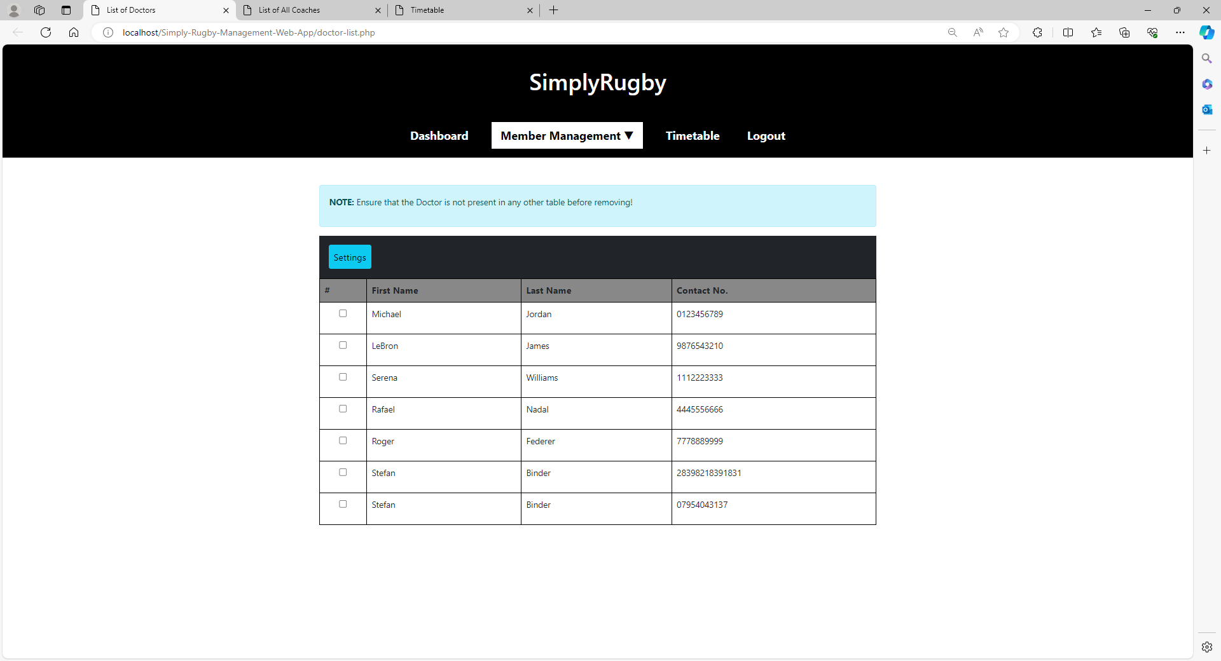

**Coach List**

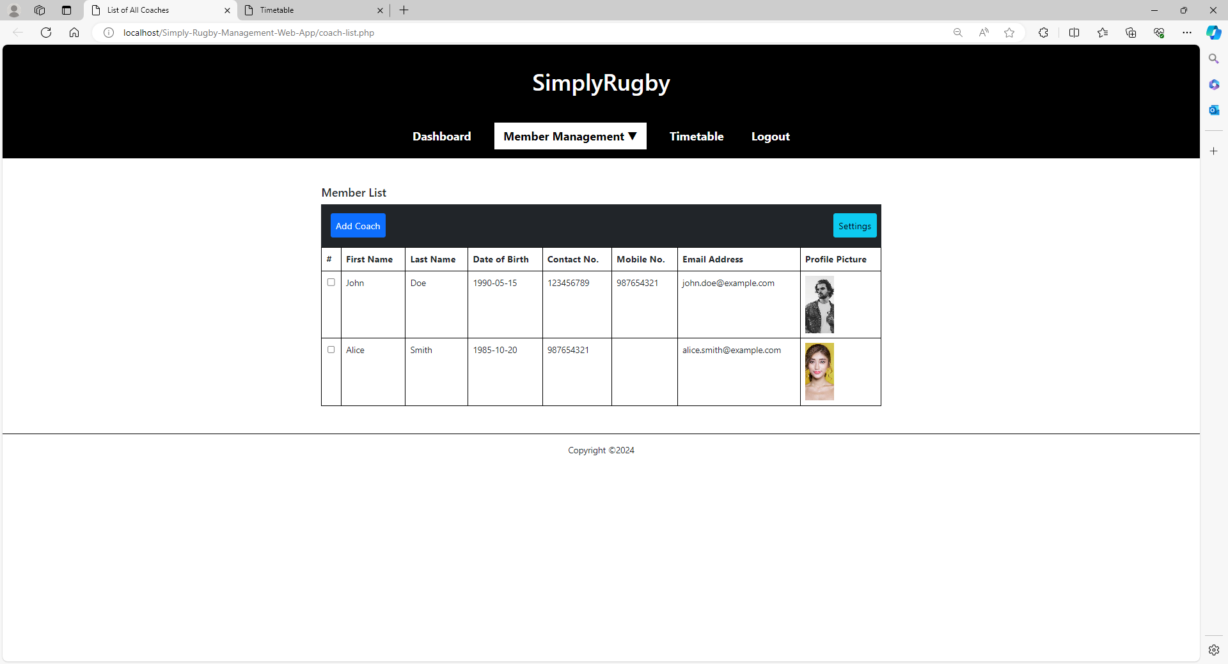

**Coach Profile Page**

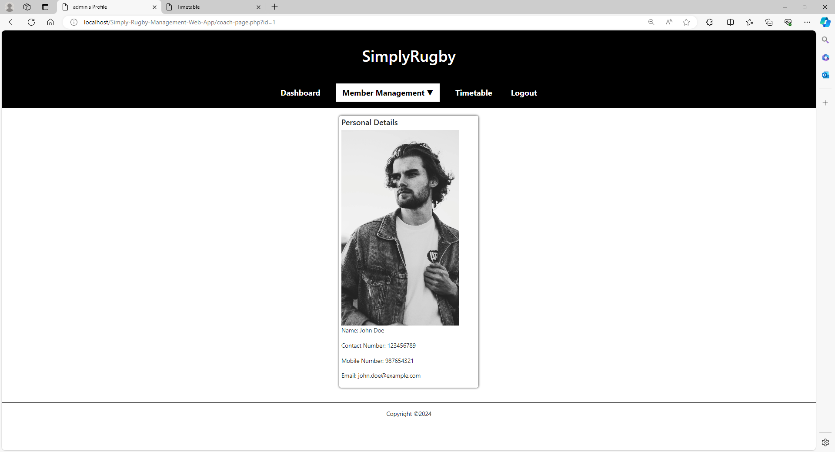

**Player Profile Page**

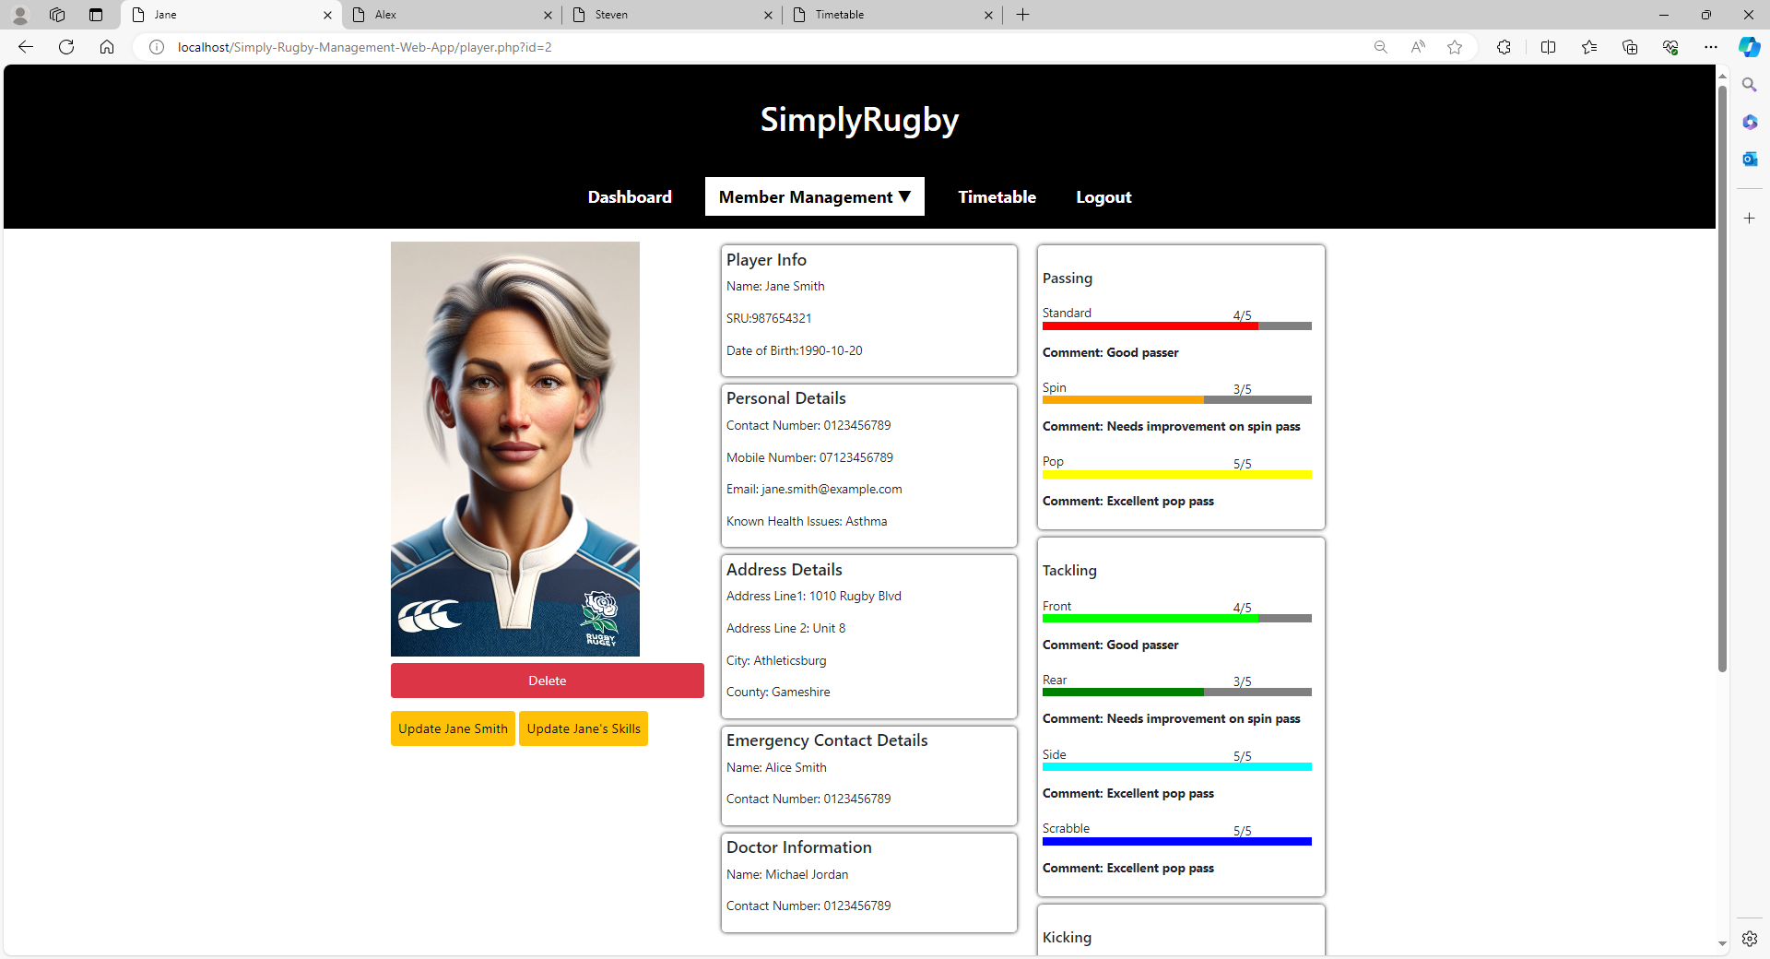

**Junior Player Profile Page**

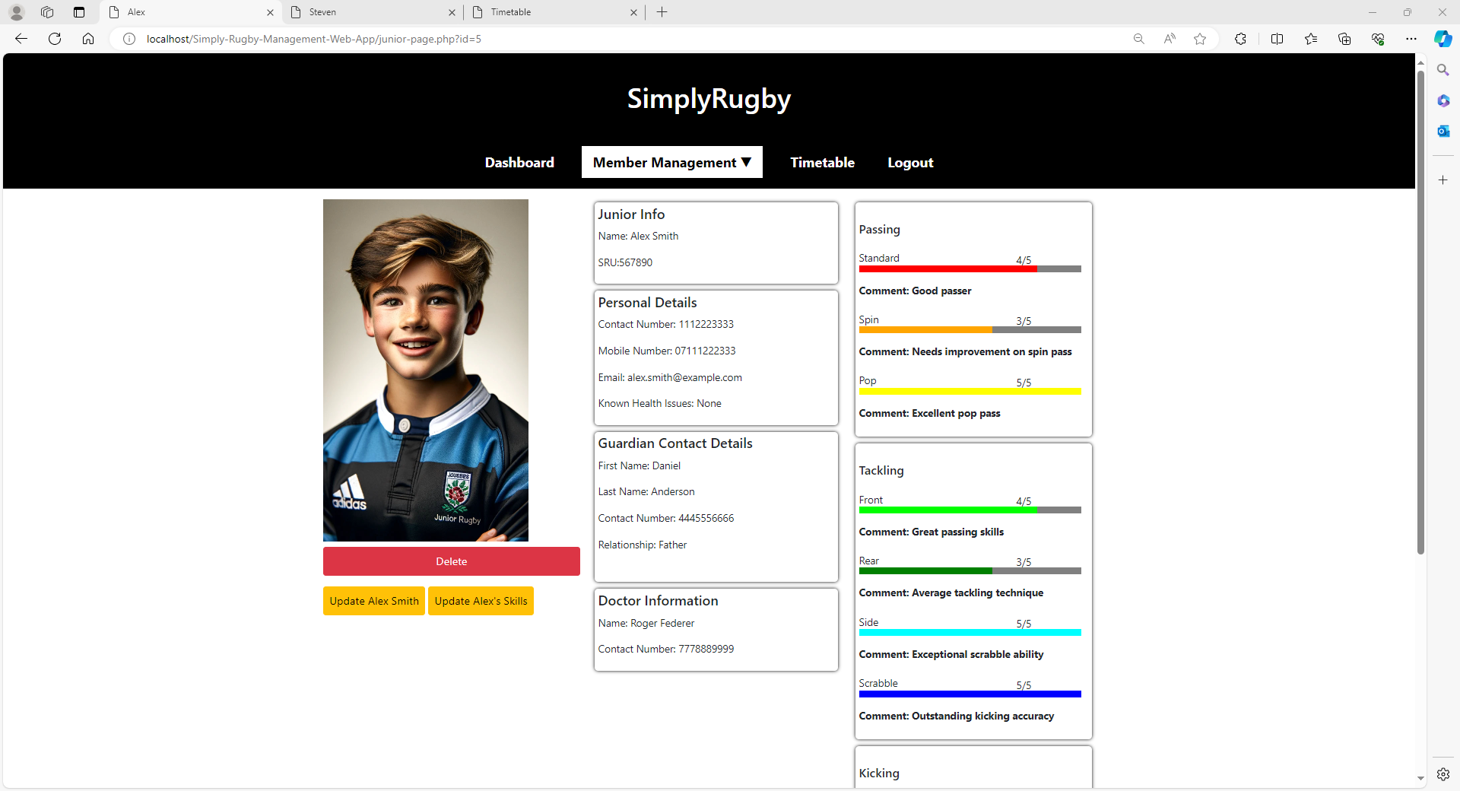

**Member Profile Page**

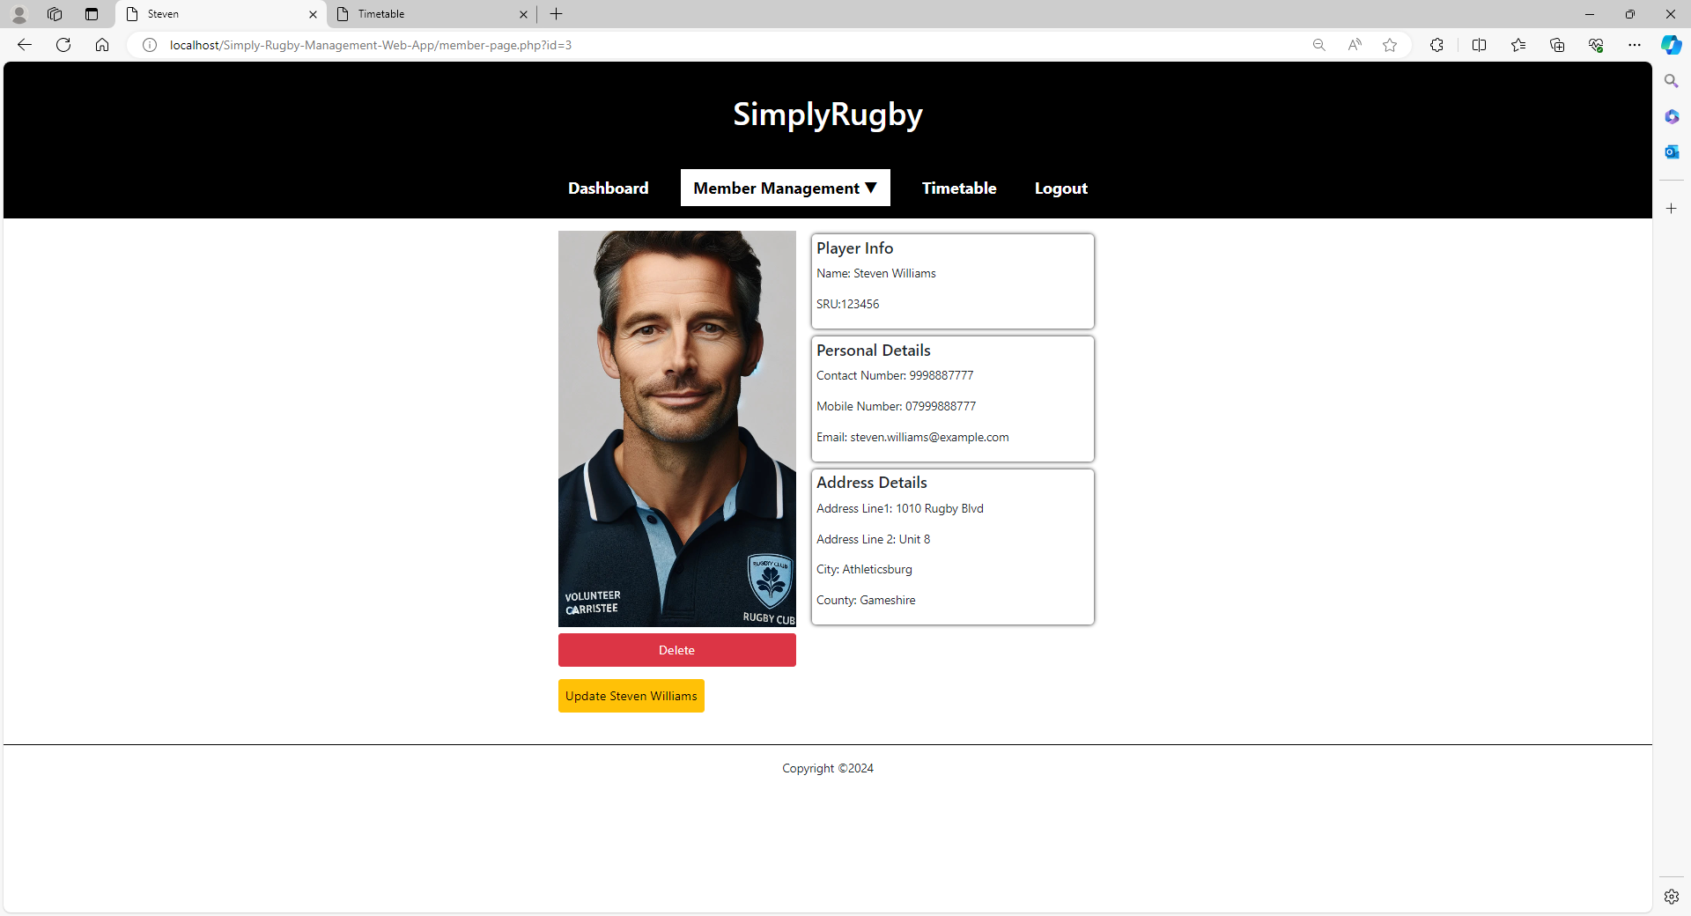

**Login Page**

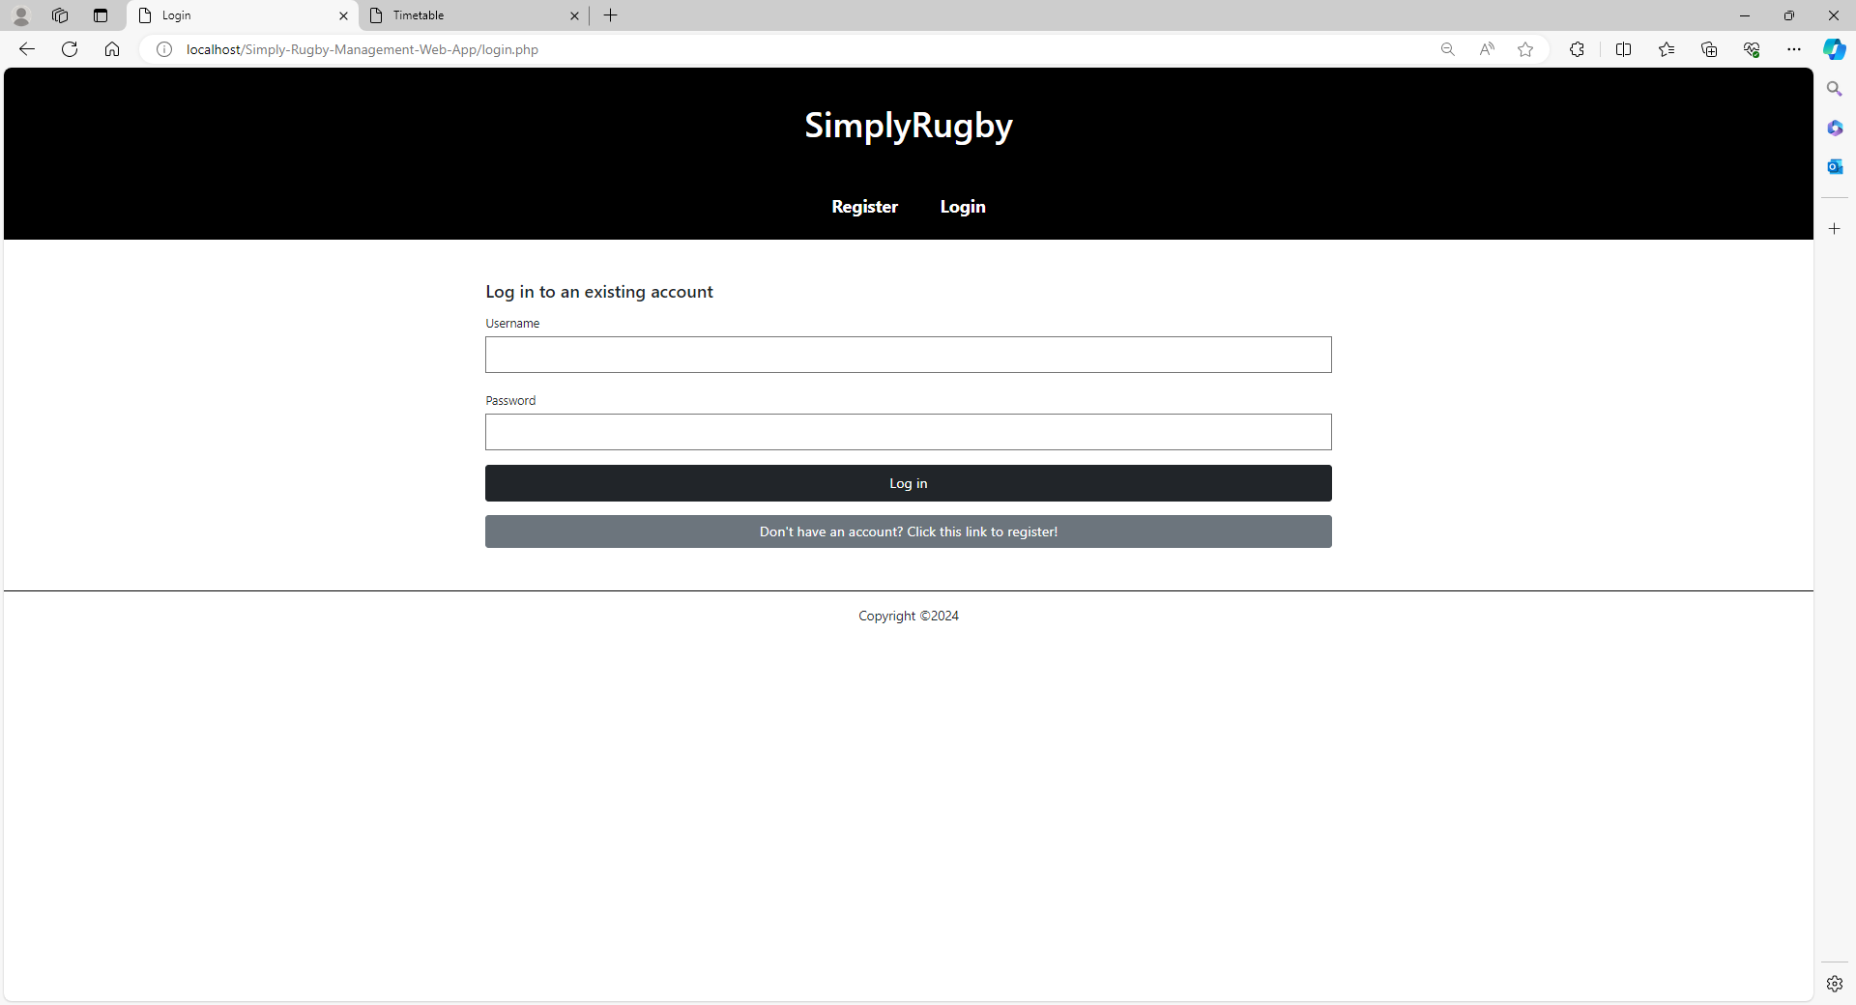

**Registration Page**

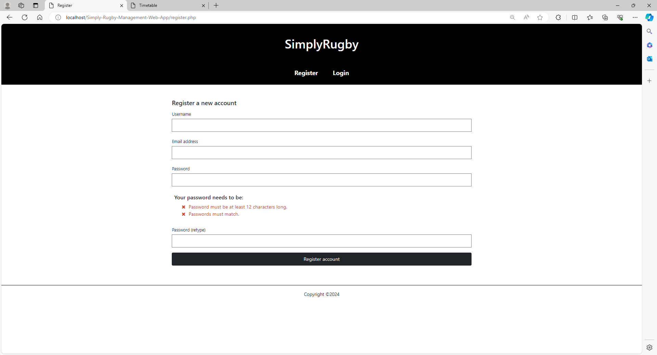

# Test Strategy

My test strategy is very similar to the testing plan paragraph in the planning document, except as mentioned earlier I have decided to abandon two forms of testing which are unit testing and system testing and instead I have replaced them with component testing and database testing.

I have gathered some responses from Microsoft forms and have transferred them onto usability checklist which I took from the multi-platform websites course materials and thought it would be a good idea to use it for this project as well.

I have filled out couple of excel tables, which are presented as .PDF files. These include tables for functionality testing which tests the functionality of each individual pages, looking for any errors or imperfections associated with a specific page.

Database testing and component testing were also done in excel and are also available as .PDF. These tests were carried out in similar manner as the functionality testing; for database testing, I was testing all my SQL queries and writing down the expected result and the actual result to see if the query outputted or did what it was supposed to, for component testing it was just the same, except I was testing if each component like images, fonts, styles, etc were loading and working as expected.

# Testing Screenshots

This section will contain all screenshots of the testing I have done for this graded unit project.